**THE SOUTH AFRICAN ARCHAEOLOGICAL SOCIETY**

**THE ARCHAEOLOGY AND CULTURE OF HITTITE ANATOLIA AND TURKEY’S BLACK SEA REGION**

**PLUS**

**THE FASCINATING REPUBLIC OF GEORGIA**

**11 TO 30 JUNE 2022 (20 DAYS)**

*The SA Archaeological Society’s 2020 tour has been postponed to 2022. It will visit Turkey’s capital Ankara, the surrounding Hittite and Phrygian region with its many archaeological sites, a section of Turkey’s largely undiscovered Black Sea region - a wild and beautiful area steeped in history, art and culture - and scenically spectacular Georgia in the Caucasus mountains. A fascinating mix of archaeology, historic religious sites, ancient cultures and wonderful scenery will feature on this tour.*

*Arriving in Ankara by train from Istanbul, our tour will show us the archaeological highlights of the Hittite and Phrygian Kingdoms, the remains of the Medieval Byzantine and Ottoman Empires, and superb scenery in the once Georgian Çoruh Valley, as well as lovely old towns, and churches and monasteries often dating back to the 4th century AD, such as the Sumela Monastery, and interesting mosques. Next witness the life and customs of a region along the Black Sea that is often very different from that of traditional Anatolia. The archaeological sites we will visit in Turkey include Gordion, the political and cultural capital of the Phrygians; Kalehöyük hosting four main cultural periods; the Iron Age site of Pteria; pre-Hittite Hattuşa, site of the discovery of the cuneiform royal archive of 30 000 clay tablets; the Hittite sanctuary of Yazilikaya; and Şapinuva, another centre of Hittite civilisation. Our tour will encompass 4 500 years of history and artefacts from this period will be seen in the museums to be visited.*

*After 11 days in Turkey, we will spend seven days in Georgia to explore the sub-tropical Black Sea region, the high Caucuses mountains, famous ancient Eastern Orthodox churches and monasteries, a fascinating archaeological and cultural heritage and, above all, superb scenery. As a* *country at the intersection of Europe and Asia, the former Soviet republic of Georgia is home to medieval mountain villages, which we will visit the upper Svaneti region bordering on Russia. Their defensive ‘khoski’* *stone towers provide a delightful spectacle. The archaeological perspective will be provided by the Vani multi-layered archaeological site dating to the ancient Colchis Kingdom, the palaeontological Dmanisi site where five 1,8-million-year-old hominid skulls with diverse physical traits have been found, and the thousands-of-years-old Uplistikhe Cave, which is considered one of the 20 most incredible cliff structures in the world. The capital, Tbilisi, is known for its diverse architecture and the cobblestone streets of its old town.*

**Tour leader:** Reinoud Boers +27 82 566 6295

**Guide in Turkey:** tba

**Guide in Georgian:** tba

**THE ITINERARY**

**Saturday 11 June: Johannesburg – Doha**

**18:00** Participants meet in front of the Qatar Airways desks at OR Tambo International Airport. Luggage is tagged before checking in.

**21:05** Depart for Doha on Qatar Airways flight QR1368.

**Sunday 12 June: Doha – Istanbul**

**06:25** Arrive at Doha International Airport.

**09:45** Depart for Istanbul on Qatar Airways flight QR 241.

**13:50** Arrive at Sabiha Gökçen International Airport (SAW) in Asian Istanbul.

After passport control and luggage collection we are met by our guide and driver for Turkey and transfer to the **Titanic Business Kartal Hotel** (www.titanic.com.tr/titanic-business-kartal?utm_source=google&utm) in Asian Istanbul **for overnight**. Remainder of afternoon at leisure.

**19:00 Dinner at a nice local restaurant.**

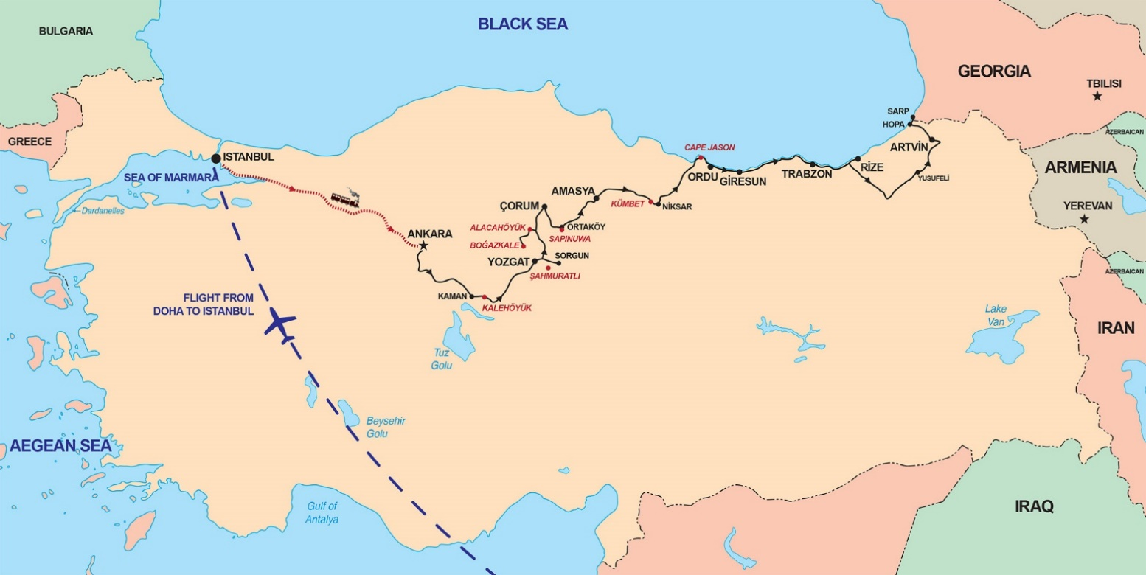

**Our tour route in Turkey**

**Monday 13 June: Istanbul – Ankara by rail**

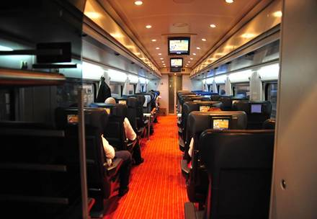**07:00** Short transfer by coach to **Pendik Railway Station**.

**07:41** Depart on the modern and comfortable **Yüksek Hizli Tren** (high-speed train) to Ankara. Travel through Anatolia’s interesting countryside in Pullman Economy (photo on left). The train has an on-board restaurant. (Departure time subject to change.)

**11:42** Arrive at Ankara Railway Station. Short transfer to the **New Park Hotel** (www.npankara.com), our hotel for **two nights**. Get settled, relax and have a snack for lunch (*own cost)*.

**14:00** Depart for the superb **Museum of Anatolian Civilisations** housed in a beautifully restored 15th century *bedesten* (warehouse). The 10-domed central marketplace houses reliefs and statues, while the surrounding halls display exhibits from the earlier Anatolian civilisations: Paleolithic, Neolithic, Chalcolithic, Bronze Age, Assyrian, Hittite, Phrygian, Urartian and Lydian. Downstairs sections feature classic Greek and Roman artefacts and a display on Ankara’s history.

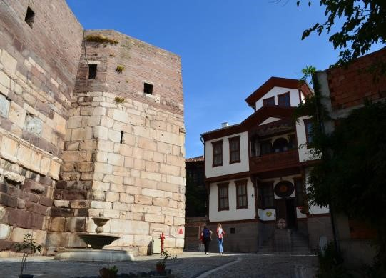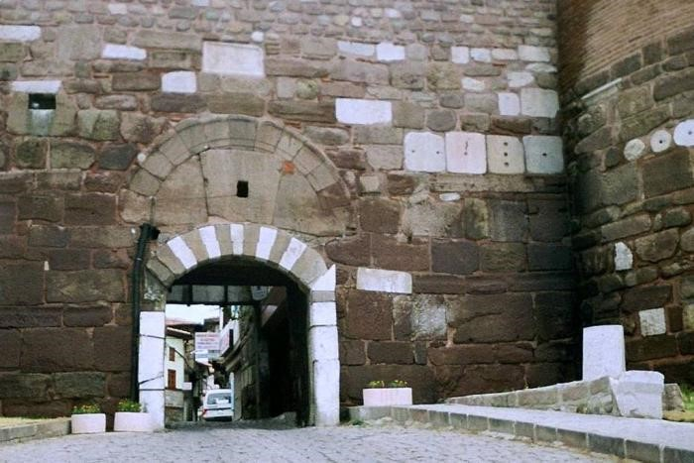

After a couple of hours at the museum, we walk to **the Citadel**. The imposing *hisar* (fortress) is the most interesting part of Ankara to poke about in. The well-preserved **Ulus quarter** with its thick walls and intriguing winding streets took its present shape in the 9th century AD, when the Byzantine emperor Michael II constructed the outer ramparts. The inner walls date from the 7th century.

**19:00** Dinner is had at **local restaurant in the Citadel**.

# Tuesday 14 June: Gordion archaeological site and Ankara

In the morning we visit the **ancient city of Gordion** [(](http://sites.museum.upenn.edu/gordion/)[www.penn.museum/sites/gordion](http://www.penn.museum/sites/gordion)[)](http://sites.museum.upenn.edu/gordion/), 95 km from Ankara. Gordion was the political and cultural capital of the **Phrygians**, one of the principal centres of the ancient world and the index site for understanding Phrygian culture and early Anatolian history. The site is included in Unesco’s Tentative List of World Heritage Sites. The excavation season will just have started and **Prof. Dr Brian Rose** will meet us and take us around the site.

Within ancient Gordion, **Yassihoyuk village** is known for its over two-millennia-old cemeteries and artefacts. The site was discovered during railway construction in the 19th century. Around 750 artefacts found during archaeological excavations, including mosaics and pebbles, are exhibited in the **Gordion Museum**. The cemeteries around the museum narrate the lifestyle of the Phrygians, who are believed to have settle in Anatolia after the collapse of the **Hittite dynasty**.

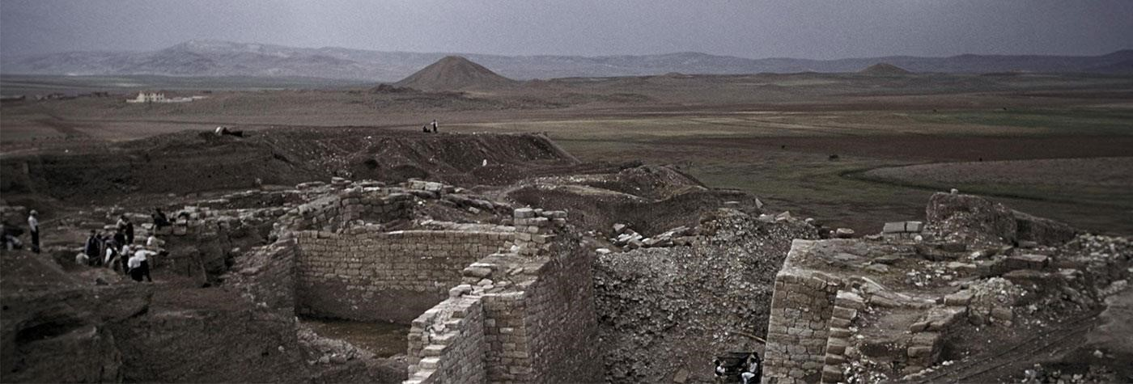 **Ancient Gordion**

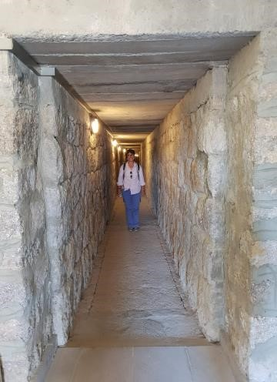

Another key attraction in Gordion is **the Midas Mound Tumulus**, or burial mound that was built by King Midas for his father. It is the second biggest burial mound in Turkey after the Alyattes tumulus in western Turkey. According to Unesco, the intact wooden tomb under the Midas Mound Tumulus has no parallel anywhere (the tunnel in the mound is shown on the right).

On our return to Ankara and a break for lunch, we visit the **monumental mausoleum of Mustafa Kemal Atatürk** (1881‒1938), the founder of modern Turkey. Built mainly of marble, it is sited high above the city and offers imposing views.

Continue to the **Temple of Augustus**, which was built after the conquest of Central Anatolia by the Roman emperor Octavian Augustus in 25 BC. The city of Ancyra (Ankara) became the capital of the newly formed Province of Galatia. After the death of Augustus in 25 AD, a copy of his autobiography entitled *Deeds of the Divine Augustus* was inscribed on the walls of the temple in Latin and Greek, as they were inscribed elsewhere on buildings in the Roman Empire. But the inscription at the Temple of Augustus, known as the **Monument Ancyranum**, is an almost completely preserved version, which makes it a unique source of knowledge for researchers.

On return to our hotel, there will be a 45-minute **historic overview of Turkey** and the area we will be visiting. **Dinner at hotel.**

**Wednesday 15 June: Ankara – Kalehöyük and Pteria Archaeological Sites – Sorgun**

Today we visit two significant sites hardly known and visited. Our total travelling distance today is 320 km. After our hotel check-out, we travel south-east to **Kaman-Kalehöyük**(www.[jiaa](http://www.jiaa)-[kaman.org/en/excavation_kl_27.html](http://www.jiaa-kaman.org/en/excavation_kl_27.html)).The headquarter of the Japanese Institute of Anatolian Archaeology, which has been conducting excavations at Kalehöyük since 1985, is situated in Kaman. The director of the Kalehöyüksite, Prof. Dr Sachihiro Omura, or Dr Kimiyoshi Matsumura, will meet us and guide us around the site (subject to confirmation).

### 

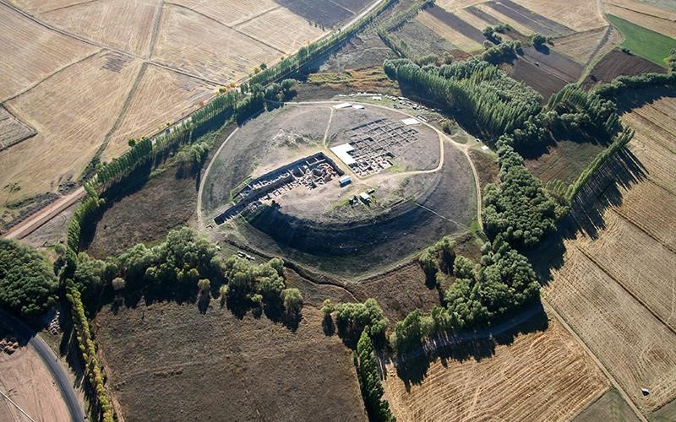 **The mound of Kalehöyük**

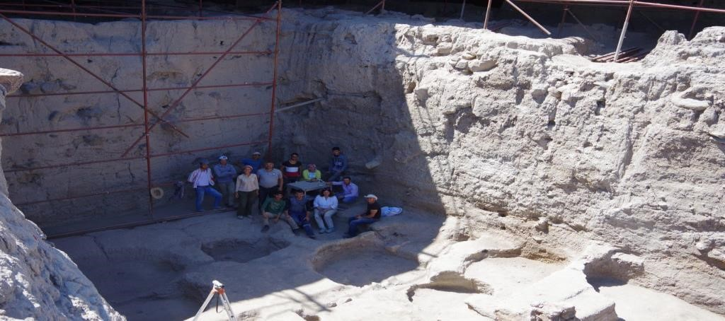Four main cultural periods have been identified at the site: **Ottoman Empire/Byzantine Period**, the **Iron Age**, **the Middle and Late Bronze Ages**, and the **Early Bronze Age**. Artefacts belonging to the Chalcolithic and Neolithic Periods have also been found. One of the objectives of the research at Kaman-Kalehöyük is to construct a cultural chronology of the site. This has led to new ideas about the ancient history of Anatolia. For example, the Iron Age Period from the 12th to 8th centuries BC, following the collapse of the Hittite Empire, has often been referred to as the ‘Dark Age’ since it seemed to have no significant culture. However, excavations in strata of the early part of this period has revealed occupied levels and material culture. **The north trench**

In the levels belonging to the 2nd millennium BC representing the Assyrian Colony Period, the **Old Hittite Kingdom and the Hittite Empire Period**, a succession of cultural levels can be seen clearly.

Following this visit we will have time to enjoy the **biggest Japanese Garden at outside Japan**. Apart from cherry trees, the garden sports a small lake with a variety of fish, an arbour to rest and art pieces in Japanese tradition. Participants can also visit the **Kalehöyük site museum** next to the garden. It received the **Best Green Museum Award** in 2010 and the **Museum of the Year in Europe** award in 2012.

After a lunch break in Kaman, we continue north to the **ancient city of Kerkenes**, stopping at the **Eco Centre at Şah Muratlı Village** for refreshments on the way**.** The centre promotes the use of renewable energy, water management, appropriate building materials and energy-efficient design for sustainable rural life on the Anatolian Plateau. Afterwards, in **Kerkenes,** we visit the **Yozgat Museum** housed in an 1871 mansion where the artefacts unearthed at the lost city of **Pteria** on **Kerkenes Dağı** (mountain) nearby are displayed.

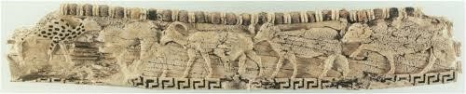

**Ivory carving from the** **Kerkenes Dağı site at Yozgat Museum**

**Dr Scott Branting**, site archaeologist at **Pteria** ([https://sciences.ucf.edu/anthropology/kerkenes](https://sciences.ucf.edu/anthropology/kerkenes/) and [www.kerkenes.metu.edu.tr](http://www.kerkenes.metu.edu.tr)), will take us around this **Iron Age site**. We will walk the last 15-minute to the site but the site Land Rover will be available. Pteria developed at the intersection of two major inter-regional trade routes. The site was first identified in 1899 and briefly excavated in the 1930s, but was not thoroughly studied until a project was initiated there by Geoffrey Summers in 1993.

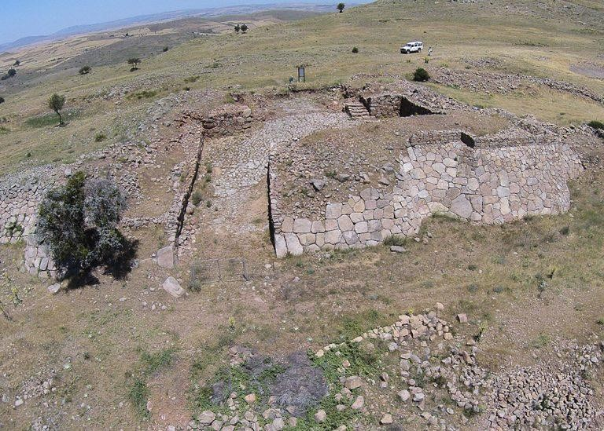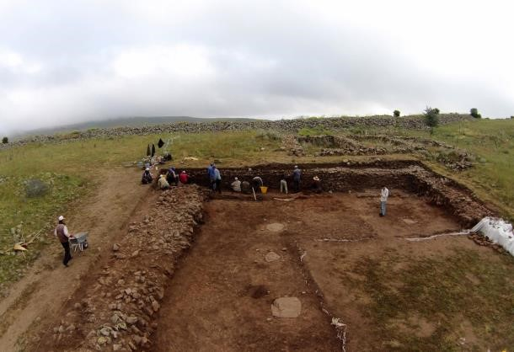

### **The lost city of Pteria on Kerkenes Dağı**

Continue to **Sorgun** for overnight at the **Büyük Thermal Hotel (one night).** Bring your swimwear (and a bathing cap) to enjoy the thermal bath and pool. **Dinner at hotel.**

**Thursday 16 June: Sorgun – Hattuşa and Yazilikaya Archaeological Sites – Çorum**

After check-out, we proceed **Alacahöyük** (travel distance today 205 km), an important city in **pre-Hittite** times. After its conquest it remained in the shadow of the nearby Hittite imperial city of Hattuşa , which dates to 1670 BC (Bronze Age). Following a visit to the **Alacahöyük Museum**, we continue to the **Hattuşa site** ([https://buffaloah.com/ a/virtual/ turk/hitt/ext.html](https://buffaloah.com/%20a/virtual/%20turk/hitt/ext.html)). It is set in the curve of the Kızıl River (the Marashantiya in Hittite sources and Halys in Classical Antiquity) and served as the Hittite capital until the collapse of the kingdom in the 12th century BC. The most important findings here are artefacts from the **pre-Hittite royal tombs** dating to 2500 BC, but the standing structures we will see are mostly from the Hittite period. Subject to confirmation, the director of the Hattuşa site, Prof. Dr Andreas Schachner, will meet our group (subject to confirmation).

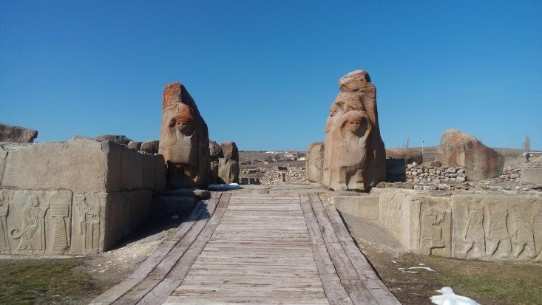 **Spinks Gate at Hattuşa**

The German Oriental Society has been excavating at Hattuşa on and off since 1906. Archaeological work is today being carried out by the German Archaeological Institute. One of the most important discoveries at Hattuşa has been the **cuneiform royal archives of clay tablets**, consisting of official correspondence and contracts, as well as legal codes, procedures for cult ceremonies, oracular prophecies and literature of the ancient Near East. One particularly important tablet details the **terms of a peace settlement between the Hittites and the Egyptians under Ramesses II, c. 1283 BC**. A copy is on display in the United Nations in New York as an example of one of the earliest-known international peace treaties. Although the **30 000 or so clay table**ts recovered from Hattuşa form the main corpus of Hittite literature, archives have since appeared at other centres in Anatolia, such as at Tabigga (Maşat Höyük) and at Sapinuwa (Ortakoy). These are now divided between four Turkish archaeological museums.

The official temple and sanctuary of the Hittite Empire, called **Yazilikaya**, is carved into a natural alcove of rocks about 2 km from Hattuşa. The shrine comprises two alcoves containing reliefs of gods and goddesses on parade and a roofless sanctuary. Initially, the alcoves were enclosed by a simple wall. Later, a small temple was added in front of the alcoves, as well as a large gateway. During an even later phase, a larger building was built and the gateways rearranged.

 

**Pre-Hittite royal tombs and the Lion Gate at Hattusa**

Since the religious ceremonies took place outside within sight of the rock relief figures, it is thought that the rites were nature-oriented. Gods, most wearing kilts and facing forward, feature in the larger alcove, while the smaller one contains mostly goddesses wearing long robes and appearing in profile. The deities' names are often inscribed over their heads. The smaller alcove seems to have been devoted to one of the past kings, either Tudhaliya II or III, while the larger alcove appears to have been used exclusively by King Tudhaliya IV.

Continue to **Çorum** where we book into the **Anitta Hotel** (<https://www.anittahotel.com>) for a **one-night** stay. Before dinner, two hours have been set aside for a **lecture on the Hittites** by **Prof. Eric Luc Jean** from the Hitite University in Çorum. Prof. Jean will join us for dinner.

## Friday 17 June: Çorum – Şapinuva Archaeological Site – Amasya in the Black Sea Region

After breakfast, we visit the **Çorum Museum**. In the Hall of Archaeology covering four floors, artefacts are displayed in chronological order. Most of these are from **Alacahöyuk**, **Şapinuva** and **Hattusa**. The reconstructions of Hittite graves and many funeral artefacts are impressive.

Following a break for lunch, we continue to **Ortakoy**, 53 km to the south-east, where the **Şapinuva Archaeological Site** ([sapinuva.info/english.htm](http://www.sapinuva.info/english.htm)) is situated at the end of the Kelkit Valley, south of the Black Sea mountain range in north-central Anatolia. Here lies the entrance to Anatolia from the Caucasus. Prof. Jean will show us around.

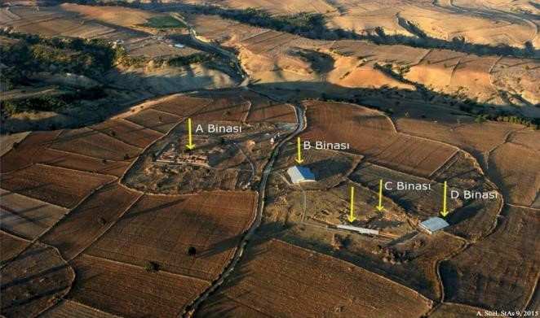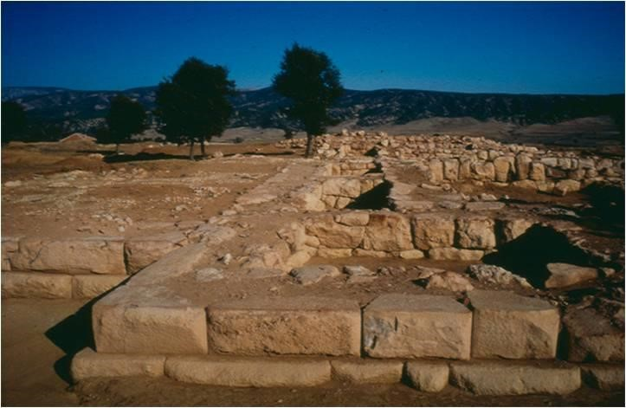

**Şapinuva Archaeological Site**

Sapinuwa served as the royal city of the Hittites for some time. The first survey of Shapinuwa was conducted by Ankara University in 1989. A monumental 3 500-year-old structure built to a unique plan, dominant on the plateau, was uncovered. Because of the building’s great size and the quality of construction, researchers speculate that it served as a government building or palace. The view from here is impressive.

We continue north-east to the hinterland of Black Sea Region (travel distance: 93 km). Our destination is **Amasya**, the birthplace of Strabo (c. 64 BC to AD 24), a Greek geographer, philosopher and historian who lived in Asia Minor during the transition of the Roman Republic into the Roman Empire. We follow the Yeşilırmak or ‘Green River’ to Amasya, which is claimed to be the loveliest town in the Anatolian interior and was referred to as **Shahzadahs** in the *Ottoman Classics*. The river bisects the town, its banks are lined with the stately 19th century homes and the massive rock tombs of the K**ings of Pontus** loom overhead. It was an important centre through Hellenistic, Byzantine and Turkish times.

We will stay for **two nights** at the **Büyük Amasya Hotel** situated on the Yeşilırmak river ([www.facebook.com/ pages/category/Hotel/ B%C3%9CY% C3%9CK-Amasya-OTEL%C4%B0-289661841393522)](http://www.facebook.com/%20pages/category/Hotel/%20B%C3%9CY%25%20C3%9CK-Amasya-OTEL%C4%B0-289661841393522)). **Dinner be at the hotel restaurant,** which overlooks the river.

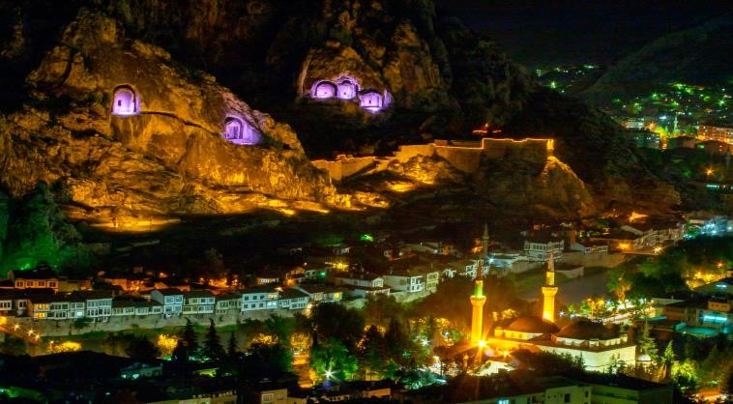 **Amasya, the Shahzadahs of the Ottoman Classics**

## Saturday 18 June: Amasya

The most pleasant way to explore this beautiful city is on foot. We first visit the **Medrese of the Grandağa** whose octagonal plan is rare in Ottoman architecture, and the **Darüşşifa (the Asylum)** built around 1308 in the name of the provincial ruler, Sultan Mehmet Olcaytu and his wife Ilduz Hatun. After a lunchbreak we cross the old bridges over the Yeşilırmak to see **traditional Amasya houses** and visit the 19th century **Hazeranlar Konağı mansion** situated within the Roman castle walls. Continue to the **Sultan Beyazit II** c**omplex (Külliye)** dating from 1486 and the **Rock Tombs of the Kings** from the Hellenistic Period (323 BC to the emergence of the Roman Empire in 31 BC). Our last visit is to the **Amasya** **Regional** **Museum** to examine gravestones from several periods and mummies from the 14th century. In terms of their mummifying technique, they are different from other examples of mummies found elsewhere in the world.

**Dinner will be at a local restaurant.**

**Left:** **Teshup, the Hittite storm god. This 15th century BC statue is the only one in existence.**

**Right: Royal burial mask from the Roman period (2nd to 3rd century AD) with a gold-leaf crown, and golden mouth and eye folds.**

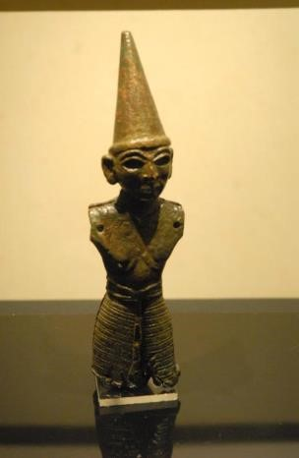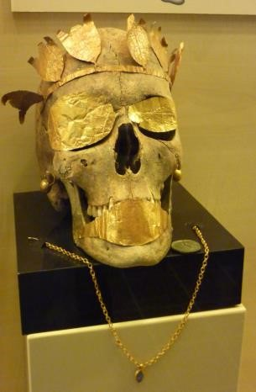

## Sunday 19 June: Amasya – Niksar – Cape Jason – Ordu

Today we travel 335 km along a scenic route to the heart of the Black Sea coastline at **Kümbet**, stopping at **Niksar,** which served as the capital of the Danishmend dynasty in the 12th century. Its **Ulu Cami** (Grand Mosque) built in 1145 is one of the earliest Turkish mosques in the country. Continue to **Cape Jason** on the coast. This rocky outcrop gets its name from the mythological adventurer Jason and his companions, **the Argonauts**. Against all odds these fearless adventurers travelled beyond the then-known world in search of the magical **‘Golden Fleece’**. It is thought that Jason harboured his famous ship, the *Argo*, at this location on his way to the Kingdom of Colchis. According to legend, this is the first ship ever to have made it into the Black Sea through the currents of the Bosporus Straits. Jason’s story is possibly validated by archaeological discovery of the remains of an ancient temple underneath a ruined church constructed by local Greeks 150 year ago.

On the way from Niksar to **Ordu** we drive up an Alpine *yaylalar* (meadows), a feature of the eastern Black Sea Region and stop at the Persembe *yayla,* which lies at a fresh and cool altitude of 1 500 m and is surrounded by lush forests and meadows full of flowers.

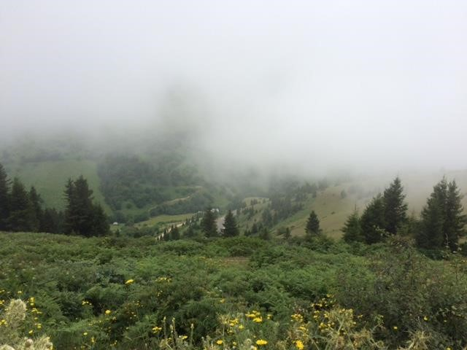  **Alpine *yayla***

## At Ordu, we drive to the top of Boztepe Hill for excellent views. Our overnight is at the Radisson Blue Hotel on the hill ([www.radissonhotels.com/en-us/hotels/radisson-blue-ordu?cid=a:se+b:gmb+c:emea+i:local+e:rdb+d:eerut+h](http://www.radissonhotels.com/en-us/hotels/radisson-blue-ordu?cid=a:se+b:gmb+c:emea+i:local+e:rdb+d:eerut+h): TRQOR1). Dinner at hotel.

## Monday 20 June: Kümbet – Giresun – Sumela Monastery – Trabzon (Traveling distance: 227 km)

This morning we explore **Giresun,** situatedin a region that has the second highest rainfall in Turkey. The province is famous for its natural mineral water and its mountainous hinterland, with many rivers, valleys and high meadows. Up to a height of 800 m the hillsides are planted with hazelnut groves producing the world’s finest quality. Giresun is a corruption of the ancient name Kerasion or Kerasus, meaning city of cherries, from the Greek word for cherry, *kerasi*. The cherry tree was carried from here throughout the world. We wander through the **historic quarter of Giresun** with its old houses clustered around the **castle**. The area known as **Zeytinlik** **(Gogora)** is especially picturesque with its stone and timber homes and two 18th century churches, one of which is now a museum.

Heading east to **Trabzon** (Trebizond), the highway does not provide the prettiest vistas of the Black Sea coast, but it does pass through several attractive small towns, including **Tirebolu**, with its compact harbour and two castles, where we will make a stop. The Çaykur tea-processing plant signals your arrival in Turkey’s çay (tea) growing area.

Continue to the magnificent **Sumela Monastery**, a Greek Orthodox monastery dedicated to the Virgin Mary situated in the Pontic mountains. Built in the 4th century, the monastery is one of the oldest in the Christian world. It is said to have been founded two Athenian priests, Barnabas and Sophronius during the reign of Emperor Theodosius I (AD 375‒395). It was restored in the 6th century by General Belisarius at the request of Emperor Justinian, but it was in the 13th century that the monastery took its present-day form with financial support from the likes of Alexios III (1349‒1390) of the Komnenian Empire of Trabzon, established in 1204.

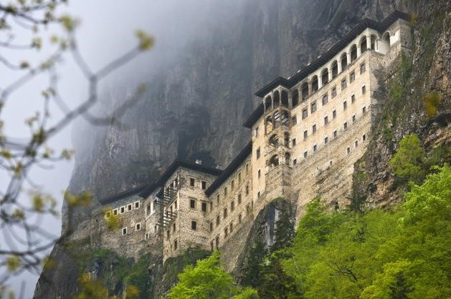 **Sumela Monastery**

Like many other monasteries, the rights of the Sumela Monastery were preserved by the Ottoman Sultans, with some special privileges awarded after the eastern Black Sea region came under Ottoman rule. During the 18th century, Sumela expanded and grew rich under the aegis of the Voivodas. Many parts were rebuilt and restored, and some wall surfaces were adorned with frescoes. However, the monastery’s golden years were in the 19th century, when large buildings and magnificent decorations were added, funded by numerous gifts from Greek Orthodox communities in Anatolia. It was also during this time that pilgrims started to come from all corners of the world to visit the majestic complex.

From April 1916 to February 1918 the Russian occupation of the Trebizond region gave hope to the restoration of a Christian state in Pontus, but in 1923, following the War of National Liberation, the monastery was deserted upon the forced population exchanges between Turkey and Greece. Tragic events continued at Sumela in 1930 when a fire destroyed all the wooden parts of the monastery (later to be fully restored).

After this visit we travel to **Trabzon** for our **two-night** stay at the **Usta Park Hotel** ([www.ustaparkhotel.com/en](http://www.ustaparkhotel.com/en)). **Dinner at a local restaurant.** On this or the next evening we will enjoy a display of **Black Sea folk dancing.**

## Tuesday 21 June: Trabzon

In the morning we visit the **highlights of Trabzon**. This will include the **Aya Sofya Museum** in what used to be the Hagia Sophia Church of the Divine Wisdom. Built in the late Byzantine period between 1238 and 1263, the church has clearly been influenced by Georgian and Sejuk design, although the wall paintings and mosaic floors follow the prevailing Constantinople style. It was converted to a mosque after the Ottoman conquest in 1461 but was used as an ammunition storage depot and hospital by the Russians before being fully restored in the 1960s.

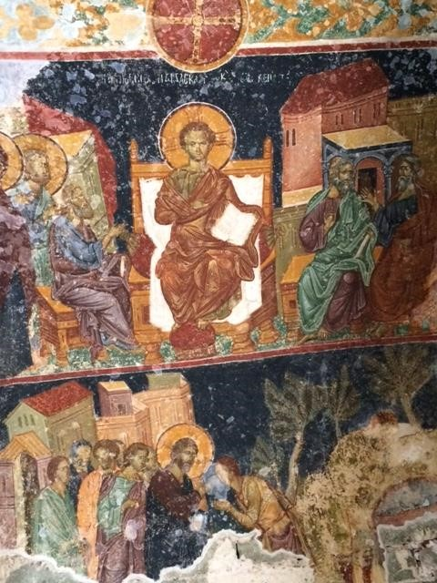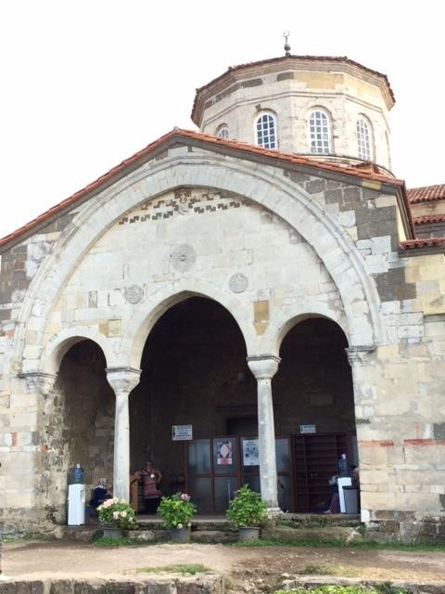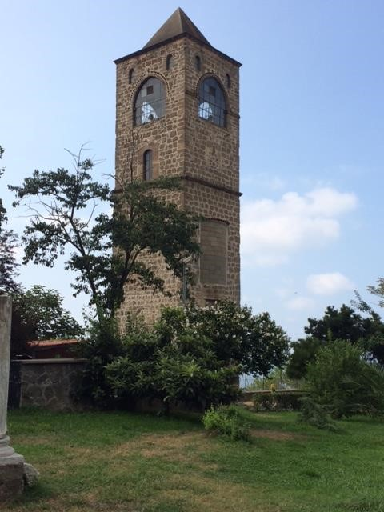

**The Aya Sofya Museum in Trabzon, formerly the Hagia Sophia Church of the Divine Wisdom**

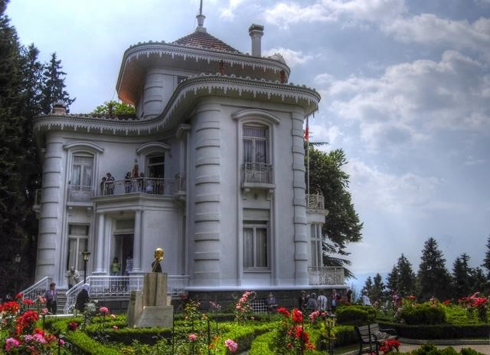Then proceed to the **Archaeology Museum of Trabzon** in the Kostaki Mansion, recently opened after decades of restoration. Italian-designed, it was built as the residence of a local Greek banker at the turn of the 20th century and displays conspicuous wealth that is dazzling even by late-Victorian standards. The archaeological collection housed in the basement contains a beautiful Roman statue of Hermes. We also have a look at the **City Museum** with beautiful exhibits of Trabzon’s geographic and economic structure, architectural and urban texture, traditional crafts, flora and fauna**.** We carry on to the **Atatürk Pavilion**, which was built by the banker Konstantin Kabayanidis in the early 19th century as a summer residence. Atatürk visited Trabzon three times and presented all his property to the Turkish nation. He said: ‘Man’s wealth must be in his spiritual personality. The property and possession are giving me the weight. I feel relieved to give these to my people.’

After a lunch snack, we **wander through the walled middle city**, the fortress and the bazaar district until **dinner is had at a local restaurant.**

## Wednesday 22 June: Trabzon – Firtina Deresi - Çoruh Valley – Artvin - İşhan – Maradit

### Check out of hotel. Although the distance to be travelled today is only 245 km, it will be a long day requiring an early start because of road conditions and dam construction around Artvin and Yusufeli. We may have to change the travel route to get into the Çoruh Valley. The church ruins we are to visit there are not reachable by coach and we will travel by *dolmuş,* local minibuses. We head east into the heart of Turkey’s tea plantation area, **Rize** and continue to the atmospheric valley of the **Firtina Deresi**, which was used to as a location for the Turkish film *Bal* (Honey). This a wonderful place to experience the traditional life of the **Hemşin**, Muslim Armenians who arrived in the area in the 16th century. If there is time, we will do a tough but scenic walk to the restored **Zil Castle**.

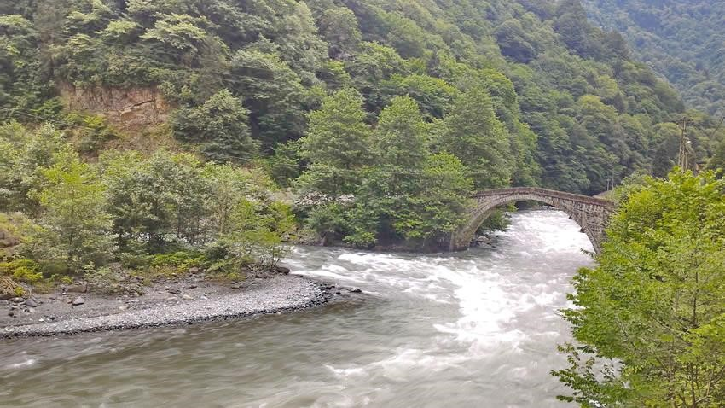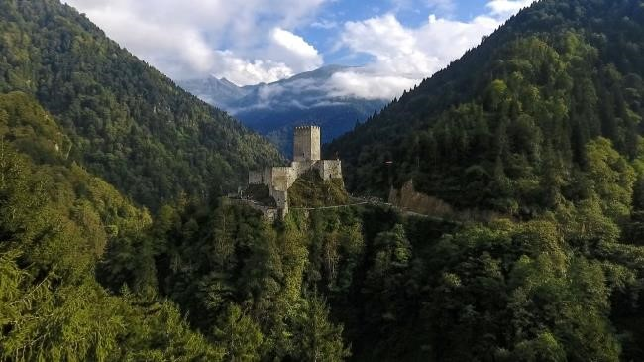

### **The Çoruh valley and Zil Castle**

**Georgians** have inhabited the **southern Caucasian Kura and Çoruh valleys** for as long as anyone can recall. Their non-Indo-European language suggests that they may have been here before the Hittites and the Urartu. During the centuries of Greek and Roman expansion, a **Georgian kingdom** held sway in Caucasia, while the ancestors of today’s Laz, a close relative of the Georgians, ruled in the lesser kingdom of Colchis. The Georgian king adopted Christianity shortly after his Armenian counterpart did, but unlike Armenians, Georgians never broke with the Eastern Orthodox Church and managed to maintain their independence in the face of Roman, Byzantine, Persian, Arab and Turkish incursions. More than a dozen major churches of the medieval Georgian kingdom hide in the remote valleys and villages of the mountainous Artvin province.

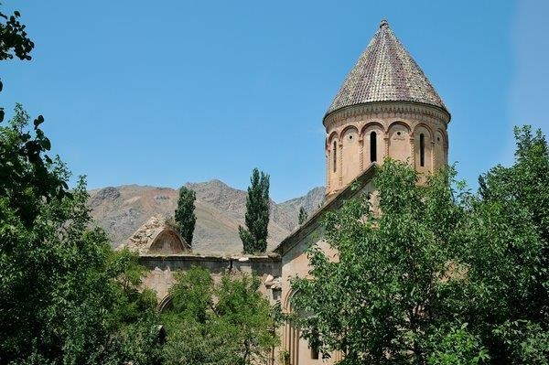

To north-west of Yusufeli**,** which will be inundated by the new dam under construction, we reach **Artvin**, where we will book into **Villa da Buttik Otel** for overnight(twin rooms in chalets, double and single rooms in the main building). There is rime for a lunch snack before taking one of Turkey’s most scenic drives. The road zigzags uphill offering spectacular views of craggy mountains, while bright green poplars and fruit trees line the valley below.

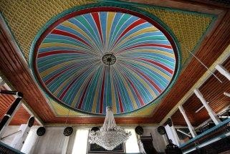In the hamlet of **İşhan** mainly wood-and-stone houses encircle a magnificent **Georgian church**, its glazed-tile dome still intact and its walls standing firm. Inside the church a cross is supported by angels and figures of saints, although these were damaged when round windows were punched through them. Unusually, the

east end of the church has a semi-circular internal colonnade, its stout columns topped by heavy capitals decorated in a variety of styles. This is the oldest part of the church and possibly dates to the 7th century. A much more refined, loftier monastic church was built in 917 and restored in 1032, with further additions being made from the 12th to 14th centuries. The west end of this church still retains traces of frescoes of which more can be seen over the windows and in the blocked-off western end of the nave. The church retains some fine external decorations, including a carved lion doing battle with a snake, and a semi-circular Georgian inscription. Right beside the church is a tiny chapel dedicated to St Mary. Its Georgian inscription says that King Bagrat III (1000‒1014) had it built. **İşhan Georgian Church & Maradit Ottoman Mosque**

İşhan village itself repays a quick look. Streams tumble down rocks on all sides and the sound of water is everywhere. Apples, pears, peaches and plums grow in abundance and in autumn the ground glitters with shiny pieces of fruit laid out in the sun to dry. Women halve plums, then stuff them with walnuts and cook them in butter to make *kaysefe.* Time permitting, we may this afternoon also visit the 19th century **Ottoman Mosque in Maradit** (Muratlı) village. The mosque is constructed 95 per cent wood and its interior wooden ornaments are spellbinding. We return to our hotel at Artvin. **Dinner at hotel.**

## Thursday 23 June: Yusufeli – Maradit – Hopa – CROSS INTO GEORGIA – Gonio Fortress - Batumi

## Following a leisurely breakfast, we make our way to the Georgia border, 156 km away. Between 11:00 to 12:00 we cross into the Republic of Georgia at the Sarp Gate. We meet or Georgian guide and driver and transfer to a local coach. Our travelling distance from here to Batumi is only 35 km.

## Untitled13.pngOn the way we stop at the Roman Gonio Fortress (Apsaros or Apsaruntos), the oldes t fortress in Georgia located at the mouth of the Chorokhi river. The name derives from one of the characters of the myth of the Argonauts (Apsaros: Medea’s brother Absyrtus). The earliest archaeological layers date to the 8th and 7th centuries BC. A cemetery from the 5th century BC, south of the castle, dates to the Colchic Kingdom. Plinius II was the first to mention Apsirtus in the 1st century AD. The high walls, 900 m in extent, were built in the second half of the 1st century AD. Gonio became a centre of Roman culture and imperial power, housing up to 1 500 soldiers until the 4th century and featuring a theatre and a hippodrome. In the mid-6th century, Gonio became a Byzantine stronghold and in the 12th century part of the Georgian kingdom. In the 16th century an Ottoman garrison was stationed here. After the Russian-Turkish war of 1877‒1878 Gonio became Georgian again. Visit the small archaeological museum.

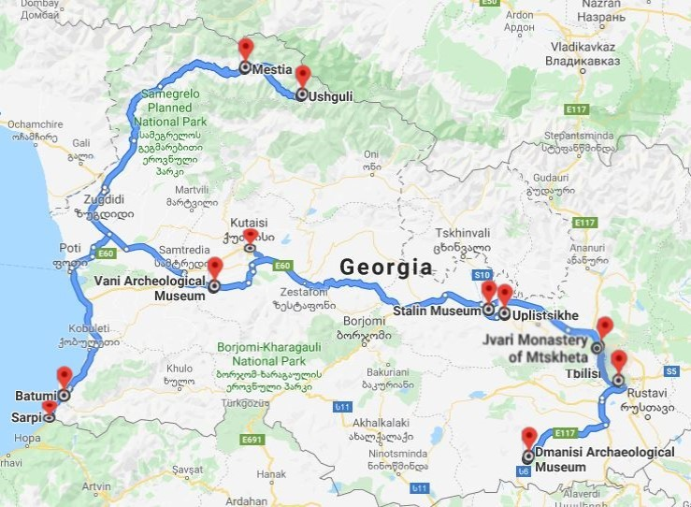

**Georgia tour route**

Around 13:30 we check into the stylish, centrally situated **Boutique Hotel O. Galogre** (see booking.com)with rooftop terrace **for one night**. Remainder of afternoon at leisure. The modern and subtropical seaside town of Batumi is situated at the foot of the **Caucasus mountains**. It is the second-largest Georgian city and the capital of the autonomous republic of Adjara. The city’s buildings are spectacularly lit up at night.

**17:00**: We meet for a **three-hour walking tour of Batumi**. By a cable car 2 586 m long we will travel to a height of 256 m to visit Georgia’s famous **monument of** **Ali and Nino**. It epitomises a well-known love story that inspired Georgian artist Tamara Kvesitadze to create this monumental moving sculpture in 2010. The giant metal artwork, also known as the ‘Statue of Love’, comprises two figures made of stacked segments that at 7 pm each day slide towards each other and merge. Continue to the 145 m high **Alphabetic Tower**, whichsymbolises the uniqueness of the Georgian alphabet and the country’s people. After an opportunity to climb the tower to enjoy the view, we walk along the boulevard to see the **Medea Statue** ofa Colchian princess of Greek mythology and pay a visit to the Italian-style **Piazza**. We end the day with **dinner at a local restaurant** thatserves delicious Georgian food.

**Friday 24 June: Batumi – Svaneti – Mestia**

**08:00:** We depart on a 265 km, five-hour journey to **Mestia**, a small town in the **upper** **Svaneti Region** that lies at a height of 1 500 m in the **southern Caucasus** and borders Russia. Here, we will enjoy scenery characterised by snow-capped peaks, glaciers and deep gorges that remind of Switzerland or New Zealand. Among the highlights are medieval villages inhabited by the Svans that are dotted with ***koshki***, defensive stone tower homes built between the 9th and 13th centuries. Around 175 koshki survive in the region today. The Svaneti region is less developed than the rest of Georgia. It can be a rainy place and is cooler.

**13:00**: On arrival in Mestia we book into the 4-star **Hotel Posta** (<https://posta-ge.book.direct/en-gb>) **for two nights.** Free time to settle in, relax and have a bite to eat.

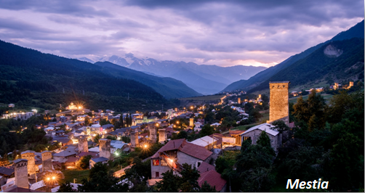

**15:00:** Visit the **Svaneti Museum of History and Ethnography**, which was founded in 1936. It houses important and valuable archaeological and ethnographical materials, as well as a rich collection of Georgian manuscripts, icons, etc. Some of these collections were donated to Svaneti churches by Georgian kings. Also to be seen are items from Syria, Sasanian Persia, the Byzantine Empire and Venice. Our last visit of the day is to a koshki, the **Margiani tower,** to explore the beauty of Svanetian towers from the inside.

**19:00:** **Dinner at a local restaurant.**

**Saturday 25 June: Mestia ‒ Ushauli – Mestia**

**10:00:** We start on a two-hour, 33 km journey by **4WD vehicles** to **Ushauli**, an alpine community of Svans situated at 2 200 m above sea level in a hard-to-access area. Here four ancient settlements, **Zhibiani, Chvibianu, Chazhashi** and **Murkmeli**, are located in the upper reaches of Inguri river south of the 5 193 m high Mount Shkhara, the highest point in the Caucasus range. *Khoshki* are a feature of this area.

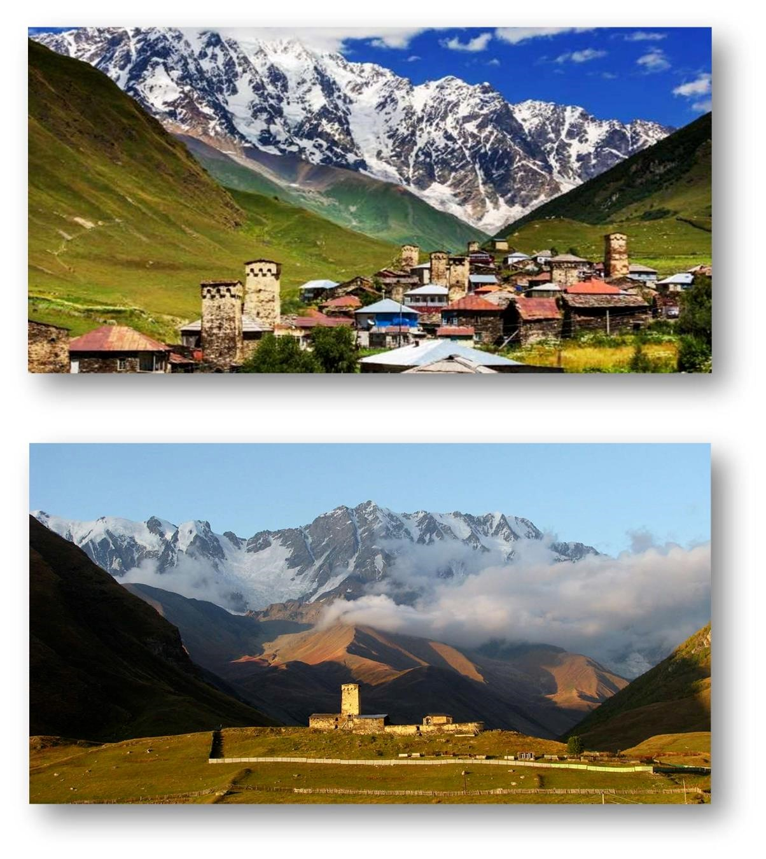

***Ushguli***

***Lamaria church***

Most of structures seen here date back to the 9th or 10th centuries. The villages have not changed much in the last 200 to 300 years*.* On all sides the villages are surrounded by glaciers and snow-capped mountain peaks. The landscape creates a grandeur as if painted by a skilful master. We will visit **Lamaria church** (Church of the Assumption of the Mother of God), which has regular services. Perhaps we will have time to attend one. The locals believe that Queen Tamara, who was a central figure in the Svans’ history, was buried under this church. They consider her to be a Christian benefactor who built all their temples and gave generous gifts to the churches.

After four hours in this superb area, we brave the road back to Mestia at 16:00.

**19:00: Dinner at a local restaurant.**

**Sunday 26 June: Mestia – Vani Archaeological Site – Prometheus cave ‒ Gelaty Monastery ‒ Kutaisi**

# 7:30: We commence on a five-hour journey to the Vani Archaeological Site located on a hill of the town of Vani in western Georgia. We will travel a total of 330 km today.

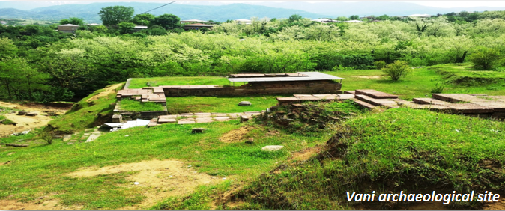Vani was a vibrant urban settlement from the 8th century BC to the mid-1st century BC. The city’s ancient name is unknown but two competing hypotheses identify the site with the **Surium** of Pliny the Elder or the **Leucothea** of Strabo. This is the best-studied Georgian site in the hinterland of an ancient region, known to the Classical World as **Colchis**, and is listed as an Immovable Cultural Monument of National Significance. We will explore the multi-layered site and the remains of fortifications and temples. Locally produced and imported Greek pottery, sophisticated local goldwork and other artefacts are on display at the **Vani Archaeological Museum**.

Thereafter we visit **Prometheuse** or **Kumistavi Cave**, which was discovered in 1984. The karst cave is about 11 km long, has 22 halls and hosts lakes and rivers, of which 1 060 m and six halls are open to visitors. This is the biggest cave in Georgia. We will travel through the cave on foot.

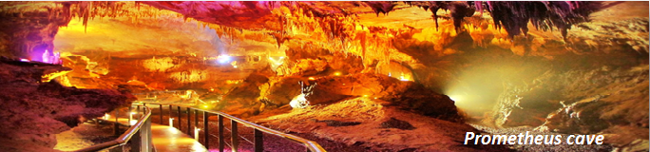

After about an hour at the cave, we continue to the **Gelaty Monestary,** one of the largest medieval monasteries in Georgia and a **World Heritage Site** near Kutaisi. A masterpiece of the **Georgian Golden Age**, Gelati was founded in 1106 by King David IV. The architectural ensemble of the complex is situated in a green glade. There is the **St George's domed main church** with its three apses and the two-storey **St Nicolas' Church** with its arched ground floor passage. A little further away a bell-tower rises near a spring. Further along rise the walls of the 12th century **Gelati Academy**.

At **Kutaisi**, the capital of the former Wedde Agis Kingdom, we overnight at the Newport Hotel (4 star).

**20:00: Dinner at a local restaurant.**

**Monday 27 June: Kutaisi ‒ Katskhi's Pillar – Uplistikhe ‒ Gori ‒ Jvari – Meskheta – Tbilisi**

**9:00**: Our 320 km journey today will first take us to the unique **Katskhi Pillar**, a limestone monolith about 40 m high overlooking a small valley. On the 150 m2 column top stands a small church built in 2009. Archaeological research has determined, however, that the earlier ruins were a hermitage with a burial chamber, a wine cellar, a curtain wall and three hermit cells dating from the 9th or 10th centuries. Venerated by locals as the **Pillar of Life** and a symbol of the True Cross, it has become surrounded by legends, for example that the hermitage was dedicated to Maximus the Confessor, a 7th century monk. A Georgian inscription paleographically dated to the 13th century indicates that the hermitage was still extant at the time. Each day, the monks living below the pillar make the pilgrimage to the top of the rock, a nerve-jangling ascent by means of a narrow metal ladder. Praying at the top is said to bring them closer to God.

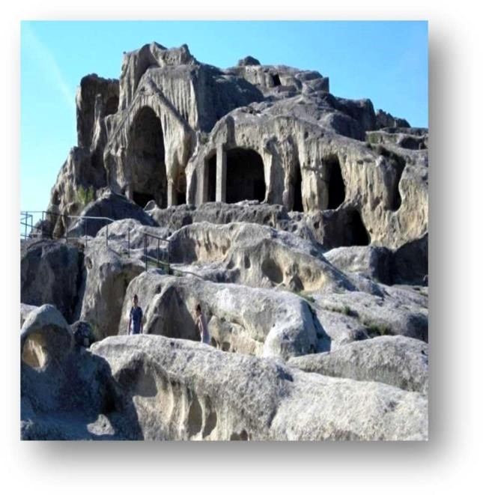

***Uplistikhe***

We continue to the **Uplistikhe cave** situated on a rocky massif 15 km east of **Gori**. The name literally means ‘Fortress of God’ and it is mentioned in chronicles from the earliest times. The ruins are considered among the 20 most incredible cliff structures in the world. Uplistikhe’s history began in the 1st to 2nd millennium BC and it became an important religious, political and cultural centre in the **Hellenistic and late Antique periods** (c. 400 BC to c. 5 00 AD). Archaeological excavations have brought to light extraordinary artefacts dating from the **late Bronze Age until the late Middle Ages**.

Rock-hewn **Uplistikhe town** has played a significant role in Georgian history over some 3 000 years. In 13th century it was ravaged by the Mongols. A break for lunch is made in **Gori**,the town in which Stalin was born in a house that is fully preserved. We will visit the **Stalin Museum**, which exhibits scenes from the life of the leader.

Then proceed to the historic town of **Mtskheta**,20 km northwest of Tbilisi, to visit the **Jvari Monastery**, which dates to between 590 and 605. Here we have a rare case of an Early Medieval Georgian church surviving to the present day almost unchanged. The church is the founder type of [Jvari-type](https://en.wikipedia.org/w/index.php?title=Jvari_type&action=edit&redlink=1) church architecture that is prevalent in Georgia and [Armenia](https://en.wikipedia.org/wiki/Armenia). Built on the top [Jvari Mount](https://en.wikipedia.org/w/index.php?title=Jvari_Mount&action=edit&redlink=1), the monastery is an example of harmonious connection with the natural environment, characteristic to Georgian

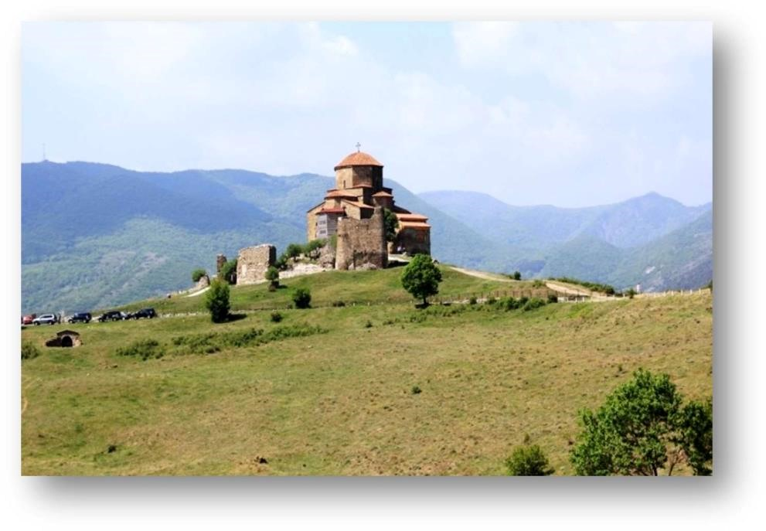

***Jvari Monastery***

architecture. This **World Heritage Site** has its legendary origins in the early 4th century when [Saint Nino](https://en.wikipedia.org/wiki/Saint_Nino), a female evangelist credited with converting King [Mirian III of Iberia](https://en.wikipedia.org/wiki/Mirian_III_of_Iberia" \o "Mirian III of Iberia) to [Christianity](https://en.wikipedia.org/wiki/Christianity), erected a large wooden (or vine) cross on the site of a pagan temple. A small church was erected over the remnants of the cross in c.545 and named the **‘Small Church of Jvari’**, which can still be seen adjacent to the main church. In the 10th century the church was burned by [Arabs](https://en.wikipedia.org/wiki/Arabs), but it required only minor repairs.

Our last and most significant visit of the day will be to the **Svetistkhoveli Cathedral** (Living Pillar Cathedral), the first and principal cathedral of the Church of Georgia and a **World Heritage Site**. The cathedral is known as the burial site of Christ's mantle and was the site for the **coronation and burial of Georgian kings**. It dates to the 4th century when St Nino chose the site. The original basilica was built during the reign of King Mirian III from Iberia. The cathedral was damaged frequently, notably by invading Arabs, Persians and Timur, as well by earthquakes. The current cross-in-square structure was built between 1010 and 1029. It was the largest Eastern Orthodox cathedral in Georgia until the **Holy Trinity Church** was consecrated in Tbilisi in 2004. Many of its priceless frescoes were lost due to being whitewashed by the [Russian Imperial](https://en.wikipedia.org/wiki/Russian_Empire) authorities.

A short hop brings us to Georgia’s capital **Tbilisi**, where we book into the 4-star **Hotel Old Kopala** and the 3-star **Hotel Blue Kopala** across the road (www.kopala.ge/kopala-hotel)for two nights. Breakfasts will be had at Hotel Blue Kopala. The rooms of both establishments are similar – the lack of breakfast facilities accounts for the Blue Kopala’s lower rating.

**20:30:** D**inner at a traditional Georgian restaurant with a dancing show.**

**Tuesday 28 June: Tbilisi city tour and optional ‘Welcome to Georgia’ musical show** (if showing)

**09:00:** Today we discover Tbilisi. Our first visit is to the **Metekhi Church** with its **King Vakhtang Gorgasali Statue** occupying a rocky outcrop above the **Metekhi Bridge.** From here we have an excellent view over the old town. The existing church was built by King Demetre Tavdadebuli between 1278 and 1289 and has been reconstructed many times since.

**Our walking tour** **of Old Tbilisi** starts in the ancient district of **Abanotubani**, which is known for its sulphur baths and features a statue that symbolises the foundation of Tbilisi and the hidden **Leghvtakhevi** w**aterfall**. Continue to the ancient **Narikala Fortress** to visit the **St Nicholas Orthodox Church.** Then we take a **cable car** to **Rike Park** to view a large-scale map of Georgia. Via the **Peace Bridge**, a pedestrian bridge over the Mtkvari river, whose structure of glass and steel connects old and new Tbilisi. Other sights include the **Gabriadze Clocktower** and **Freedom Square**, first named as such in 1918 during the foundation of the First Georgian Republic following the collapse of the Russian Empire. In the centre of the square stands the 40 m high **statue of St George**, a monument to Liberty and Victory.

**Lunch is had in a local restaurant** (*included*) before we continue for a one-hour guided tour of the **Georgian National Museum**. It displays evidence of the oldest human existence in Eurasia in addition to magnificent Medieval Christian art, stunning gold and silver jewellery from Colchis, spectacular modern and contemporary paintings by Georgian artists, and masterpieces of Oriental, Western European and Russian decorative arts.

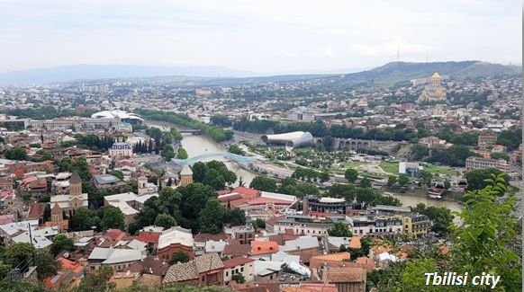

This is followed by a one-hour guided tour of the **Ethnographic Museum**, a **historic village** populated by around 70 buildings and artefacts from all over Georgia. It occupies a 52 ha area and is arranged in 11 zones featuring the traditional *darbazi*-type flat-roofed stone houses from eastern Georgia, openwork wooden houses with gable roofs of straw or boards from western Georgia, watchtowers from the mountainous provinces of Khevsureti, Pshavi and Svaneti, Megrelian and Imeretian wattle maize storage structures, Kakhetian wineries, Kartlian water mills, and a collection of traditional household articles. Return to hotel.

**19:30:** If showing, depart for the **optional 90-minute** **‘Welcome to Georgia’ musical show** (cost about UD$30 per person). Return to hotel by about 10:00. Dinner is for own account.

**Wednesday 29 June: Tbilisi – Dmanisi Palaeontological Site – Tbilisi – Doha (Qatar)**

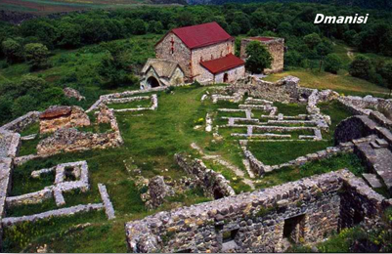**9:30**: We depart on a 215 km round trip to the **Dmanisi Palaeontological Site.** Five skulls with diverse physical traits were discovered here in 2010, which led to the hypothesis that many separate species in the genus *Homo* were in fact of a single lineage. **The site dates to 1,8 million years ago** and provided the earliest known evidence of hominids living outside Africa before stone tools dated to 2,1 million years ago were discovered in Shangchen, China, in 2018. We arrive at 11:00 for a two-hour visit, which includes a 40-minute documentary on the exploration of the site that began in the 1930s.

Return to Tbilisi by 14:30. **The remainder of the afternoon is at leisure.** Two rooms will be available at the hotel until departure for freshening up and changing.

**18:00** Depart for Tbilisi airport

**20:50** Depart with Qatar Airways on flight QR356 to Doha

**22:55** Arrive at Doha International Airport

**Thursday 30 June: Doha – Johannesburg**

**02:30** Depart with Qatar Airways on flight QR1363 to Johannesburg

**09:50** Arrive at OR Tambo International Airport, Johannesburg. End of tour.

## TOUR PRICE

### **Per person sharing: To be advised**

### **Single supplement: To be advised**

### **Included in the tour price**

All tour arrangements as per the itinerary, including economy-class airfares from Johannesburg return (tax components are subject to change); rail fare in Pullman Economy from Istanbul to Ankara; surface transportation in Turkey and Georgia by air-conditioned 30-seater coaches and other transport as indicated; accommodation based on two persons sharing a double or twin room in 3 or 4 star hotels or unrated boutique hotels as indicated; two day-rooms until departure on 1 July; all rooms with en suite facilities and air-conditioning/fans; free Wi-Fi at all hotels; all breakfasts and dinners in hotels or local restaurants, or lunches instead of dinners, as indicated; 1 ℓ of bottled water on the coach per person per day; the services of a tour leader from South Africa; professional, registered, English-speaking guides in Turkey and Georgia; all entrance fees to museums and sites listed in the programme; cable car tickets; parking and local taxes; tips to local restaurants; cultural events as indicated; VAT; gratuities to the guides and drivers.

**Not included in the price**

All lunches except as indicated otherwise; all beverages; personal expenses (laundry, room service); optional visits and entertainment, e.g. the Georgia Musical Show in Tbilisi; porter service at airports and hotels; group travel insurance/seniors’ travel insurance (see ‘Important Information’ below); visa costs (see ‘Important Information’ below); add-on fares from other centres in South Africa; and Covid-19 PCR test in South Africa, Turkey and Tbilisi.