SOUTH AFRICAN ARCHAEOLOGICAL SOCIETY
TOUR OF CENTRAL ASIA
KAZAKHSTAN, UZSBEKISTAN AND TAJIKISTAN

5 to 25 September 2023 (21 days)

TOUR PROGRAMME

Tuesday 5 September: Johannesburg ‒ Doha – Almaty

Participants from Cape Town and Durban must arrive in Johannesburg the previous day, i.e. on Monday 4 September, and overnight in view of the early departure for Doha.

05:45 Participants meet at the Qatar Airways check-in area for luggage tagging.

07:45 Depart Johannesburg for Doha on Qatar Airways flight QR1366, arriving at 17:05.

20:00 Depart Doha for Almaty, Kazakhstan, on Qatar Airways flight QR0389.

Wednesday 6 September: Almaty
03:25 Arrive at Almaty (pictured alongside). Transfer to the Mercure or Kazzhol Park Hotel. Time to catch up on sleep.
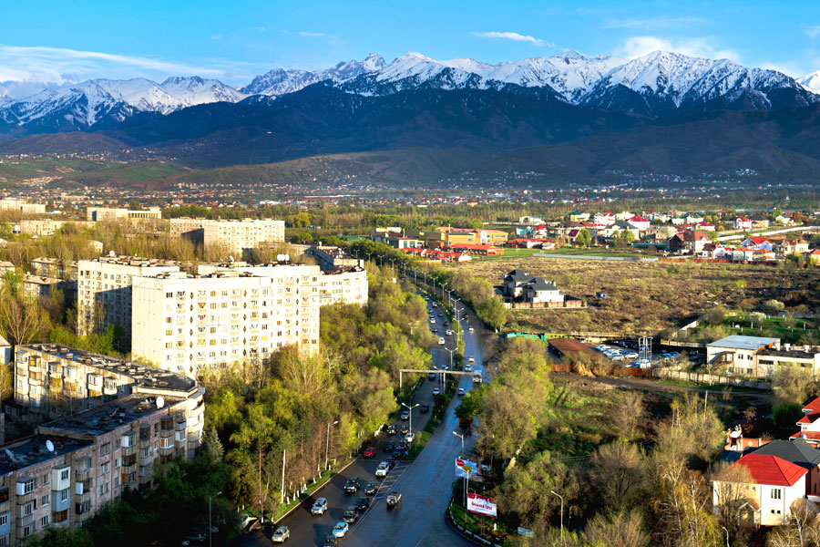
The lovely city of Almaty in the foothills of the Tien Shan Mountains was called Alma Ata when it was Kazakhstan’s capital (the capital now is Astana, which was built in the steppe to the north 25 years ago). Almaty is still the country’s largest city and lies 300 km from the border with China’s Xinxiang province. Almaty was founded by Siberian Cossacks and destroyed by an earthquake in 1911.
13:00 Afternoon tour to visit the following:
- The Central State Museum of Kazakhstan is one of the largest museums in Central Asia. It houses the most significant collection of Kazakh historical, archaeological, modern cultural and political artifacts.
- The Russian Orthodox Ascension Cathedral, also known as the Zenkov Cathedral, was completed in 1907. The 56 m high structure is built entirely out of wood without the use of nails and is claimed to be the second tallest wooden building in the world. It survived the 1911 earthquake.
- The Ykhlas Museum of Folk Musical Instruments exhibits over 1 000 musical instruments and 60 types of Kazakh national musical instruments dating back to the 17th century.

Thursday 7 September: Almaty – Tamgaly – Almaty – Tashkent
Check out of hotel and by mini-buses drive to the Tamgaly (170 km, 2-3 hours) in the Chu-Ili Mountains to view amazing petroglyphs from the Bronze Age and the 15th to 13th centuries BC in the
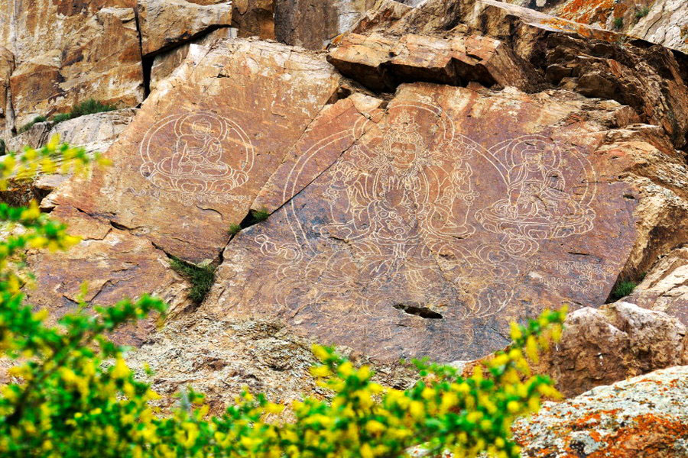
gorges of the Aurakkay mountain range. Enjoy great scenery en route. Tamgaly was declared a UNESCO World Heritage Site in 2004. After a picnic lunch, walk around the valley accompanied by a UNESCO specialist for petroglyphs. On return to Almaty after nine to ten hours, we proceed direct to the airport for our Uzbekistan Airways flight 764 departing at 18:30, arriving 19:10. Transfer to the Navruz, Ateca or Praga Hotel for four nights. Dinner is for own account.

Friday 8 September: Tashkent
Because of the destruction of most of the ancient city during the 1917 revolution and the 1966 earthquake, little remains of Tashkent's traditional architectural heritage. However, the city is rich in archaeological sites, museums and Soviet-era monuments. On our visit, during which we will be accompanied by a local archaeologist and English-speaking guide/translator, we will see:
- Aktepa archaeological excavations. The ancient settlement of Aktepa (‘White Hill’), together with other famous settlements such as Ming Urik, is among the oldest archaeological site of the Tashkent oasis. Aktepa mound encloses the remains of a large 5th century AD fort that protected Taskent from invasion until the 7th century, a palace and a Zoroastrian fire temple. The fort was surrounded by a moat and had a very narrow entrance corridor and a donjon.
- Ming Urik, an ancient settlement located almost in the heart of Tashkent, where a Zoroastrian Temple of Fire was discovered.
- Kanka, 60 km from Tashkent and identified as the city of Kharashket on a southern branch of the Silk Road, is the oldest and largest ancient oasis settlement in the Akhangaran Valley. It dates from the 3rd century BC to the 12th century AD. Archaeological excavations are ongoing. It lies near the Syr Darya River, known in antiquity as the Jaxartes. Kanka had three fortified walls constructed of rammed earth alternating with adobe and baked-brick layers. We enter the 400-ha complex through the surviving gate in the outer wall, arriving in the once densely built-up urban area (shakhristan). The second massively fortified wall with traces of watchtowers encloses an area of 50 ha. Inside this second shakhristan rises a third, even more heavily fortified wall surrounded by a 40 m wide moat. Within it, a 50 m high hill is the site of the former citadel that occupied 6,5 ha. Archaeological excavations have revealed about 20 m of cultural layers, as well as traces of fires and earthquakes and evidence of periods of urban decay and remedial filling that mark periods of prosperity. The most intense periods in the life of the city date from the 4th to 2nd centuries BC, the 6th to the 8th and the 10th to the 12th centuries (see Tour Notes).
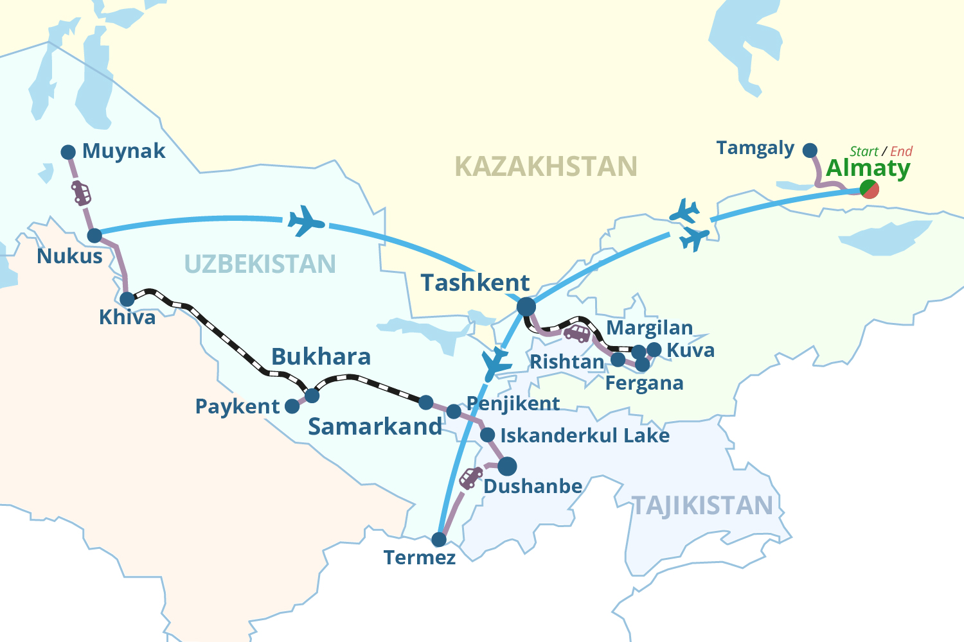
- The History Museum of Uzbekistan founded in 1876 houses a very well-preserved alabaster Buddha relief found in Termez, Stone Age implements from the early cave culture of Uzbekistan, Muslim calligraphy, and ethnic art and costumes from different parts of Uzbekistan.
- The Chorsu Bazaar nearby is a huge open-air bazaar in the centre of the old town of Kukedash where everything imaginable is on sale.
After dinner, we take the Tashkent Metro, known for its extravagant design, to Independence Square in the centre for a walk past the Navoi Theatre to Amir Timur Square.

Saturday 9 September: Tashkent – Margilan – Kuva – Fergana
07:00 After an early breakfast, transfer to the railway station. Taken an overnight bag; our main luggage is stored in our hotel.
07:55 Depart by train for Margilan, a 1st century BC city that is still the centre of the silk industry. It lies in the famous Fergana Valley with its fertile fields, fruit orchards and fat-tailed sheep. This is a high-altitude Eden reminding one of Kashmir. The beauty of the valley was destroyed by Soviet cotton plantations and industrialisation, but land was returned to private farmland ownership after 1991 and the valley has recovered much of its natural splendour. An hour from Tashkent one starts to climb into the mountains to reach Alpine meadows with flowers and distant snowy peaks. The Fergana valley is popular for pottery and silk products.
Arriving at Margilan at 12:56, we visit the Said Akhmad-Khoja Madrasah and the Yodgorlik silk factory for a tour before continuing to the small town of Kuva (40 km) (photo next page). The ancient city, known as Kuba, was situated along the caravan road that connected the Fergana Valley with Kashgar, the most western city in China. Kuva was destroyed by the Mongolians in the 13th century but by the Middle Ages it played an important economic and political role following the development of pottery, gold-working and metal-treatment handicrafts. The medieval astronomer, mathematician and scholar-encyclopaedist Abū al-Abbās Ahmad ibn Muhammad ibn Kathir al-Farghani, who served to the caliphs of Merv, Cairo and Baghdad and also gained prominence in Europe under the name of Alfraganus, was born here. He founded several large universities in Damascus and observatories in many cities of the East.
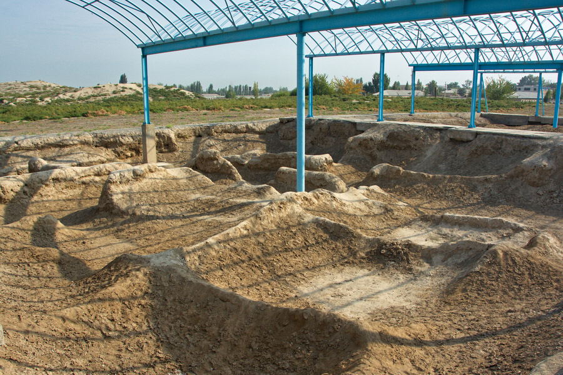
Archaeological excavations have discovered a cultic Buddhist temple containing fragments of monumental sculpture, statues of gods of the Buddhist pantheon and destroyed Buddha figurines. A black-painted head of a Shri-Devi goddess is depicted as a furious woman wearing a horrendous necklace and diadem of skulls. Many hymns glorified her as a powerful and fair zealot of the belief. Continue to Fergana (20 km) for overnight at the Asia Hotel.

Sunday 10 September: Fergana –Rishon – Tashkent
Drive to Rishon, 45 minutes away, for a visit to a ceramic museum with cobalt and green pottery and the Ok Yer village where families produce wool carpets. Return to our hotel in Tashkent by car – three passengers per car - over the scenic Kamchik Pass (2 267 m) (320 km, 5 hours).

Monday 11 September: Tashkent – Termez
05:00 Transfer to the airport.
07:15 Depart Tashkent for Termez in the south of Uzbekistan on Uzbekistan Airways flight 65, arriving at 08:15. Transfer to the Meridian Hotel for a two-night stay. Breakfast and time to relax.
Termez is an ancient Buddhist centre on the Amu Darya River in southern Uzbekistan ‒ the Oxus River of historic fame – just across the border from Afghanistan. Situated in the ancient state of Khorezm, it is considered by many researchers to be the birthplace of the Zoroastrianism, while legend holds that this was the place where Zoroaster wrote the first lines of the Avesta.
13:00 Afternoon visit to the following sights:
- Kampyrtepa, a World Heritage Site 30 km from Termez, was once a majestic and invincible fort of ancient Bactria dating to the 3rd century BC. It controls a ford over the Syr Darya River on a major route linking the Bactrian and Sogdiana capitals. In the Seleucid and Graeco-Bactrian periods the settlement is likely to have been without defences. Only later, when Graeco-Bactria had fallen under the onslaughts of nomadic tribes, the fort assumed a more prominent role and was surrounded with a defensive wall. Under Kushan rule in the 1st century AD, a fortress with massive fortifications was built and its area enlarged to 3,5 ha (see Tour Notes).
- We stop at the Jarkurgan Minaret and the Alexander the Great Bridge. The minaret with its fluted form was erected in 1109 but today only the lower 22 m high tier has been preserved. Similar to the minarets of northern India and Khorasan, it is remarkable for the wavelike shape in its brickwork, broken up with occasional Kufic inscriptions. The Alexander the Great Bridge most likely lies at the place were Alexander crossed the river 2 300 years ago.
- The Dalverzintepa archaeological site demonstrates the development of sculpture in northern Bactrian during the Kushan epoch (1st to 3rd centuries BC). Once a centre lying on one of the most important Great Silk Roads, it occupied an area of 36 ha (see tour notes).
Tuesday 12 September: Termez
We continue our tour of Termez to view the following:
- Archaeological Museum of Termez that displays artifacts mainly linked to the Graeco-Bactrian and Kushan periods. Some artifacts, such as the Buddha seated under the Bodhi tree or the head of the Kushan prince, are copies of the originals in the History Museum of Tashkent or the Hermitage in St Petersburg. The museum contains scale models of the archaeological sites of Salalli Tepe, Kampyr Tepe, Khalchayan, Balalyk Tepe and Fayaz Tepe.
- The Mausoleum of Al-Hakim al-Termezi is the main holy place in Termez. It was completed in 1390 when the region became part of Amir Temur’s empire. Abu Abdulloh Mohammed Ibn Hasan ibn Bashir al-Hakim al-Termizi was the author of religious philosophical works, a religious leader, an outstanding theorist of Islamic mysticism and founder of the Hakimi order of dervishes in the 10th century, which is considered one of the 12 sects of mysticism. A white marble gravestone was installed over the grave of the saint. Under the rule of Khalil Sultan (1405‒1409), a grandson of Temur, the largest hanaqoh, a house for wanderers, dervishes and faqihs was erected and contained impressive artworks.
- Kokildor-Ota Kanaka Mausoleum is a monumental construction of the 16th century. Originally it was a resting place for itinerant Sufi dervishes and other holy men. The building's design owes much to cultural links with Afghanistan, especially in the styling of its vaulted ceilings.
- Kirk Kiz (‘forty girls’) fortress has variously been considered a palace, an abbey, a caravanserai or a meeting place for Islamic studies. In fact, it is a typical example of the type of kushk or castle that came to dominate the Sogdian and post-Sogdian feudal periods (see tour notes).
- Sultan Saodat Ensemble is a complex of religious structures dating from between the 10th and 17th centuries. It holds the graves of the rulers of the influential Sayyid dynasty of Termez, which claimed direct descendancy from prophet Muhammad.
- The Zurmal Buddhist Stupa, in the valley of Surkhon beyond Termez, is one of the oldest buildings in Central Asia. As an ancient Buddhist religious symbol from the Kushan dynasty, the 13 m high cylindrical structure with a spherical roof symbolises the death of Buddha and his burial. It was built of a million square burnt bricks during the reign of Kanishka I, one of the most famous kings of Kushan. A special chamber for the storage of historical relics lay at the top of the stupa and above this rose a rod with ‘umbrellas of honour’, symbols of nobility and noble origin.
- The Karatepa (‘Black Hills’) archaeological site of a Buddhist cultural centre that is also known as the Royal Monastery dates to the 2nd to 4th centuries AD. The 8 ha complex comprised many monasteries and temples that were cut into the hillsides. A fragment of a Buddha image finished with blue paint (photo right) is still in place in one temple. Numerous stupas were built for the storage of relics. In the 5th century the caves were used as sepulchres and in the 11th and 12th centuries hermit Sufis found shelter here.
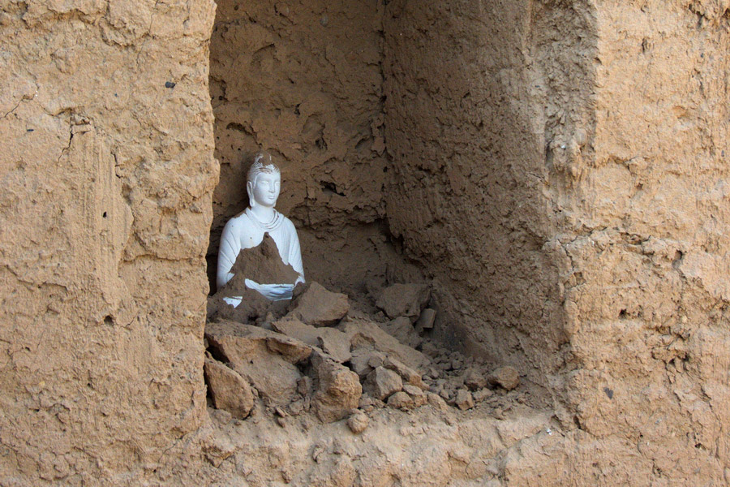
- Fayaztepe, near Karatepe, is a Buddhist site whose foundations dates from the 1st century AD, peaking at around the 3rd and 4th centuries AD. From this site numerous Buddhist frescoes and reliefs were recovered, now mostly located in the State Museum of History of Uzbekistan in
Tashkent. A famous niche shows the Buddha and two monks.

Wednesday 13 September: Termez – Dushanbe, Tajikistan
Depart for Tajikistan after breakfast. This small country is considered the ‘Nepal of the Stans’. Cross the Uzbek-Tajik border at Sariosiyo (180 km, 3 hours). Change coaches at the border. We enter a country that lies on the Pamir Mountains, 90 per cent of which is covered by high glacier-clad peaks, many of them over 6 000 m high. Tajikistan is where Zoroastrian, Buddhist, Hellenistic, Islamic and unique Pamir cultures developed for thousands of years. The country devolved into civil war following its dissolution from the USSR in 1991.
Proceed to Dushanbe (80 km, 2 hours), the capital of Tajikistan. On the way visit the 18th century Hissar Fortress, two madrassahs from the 18th and 19th centuries and a mausoleum from the 16th century near the fortress (60 to 90 minutes). In Dushanbe there could be free time depending on the time spent crossing the border. Check into the Hotel Serena for two nights.

Thursday 14 September: Dushanbe
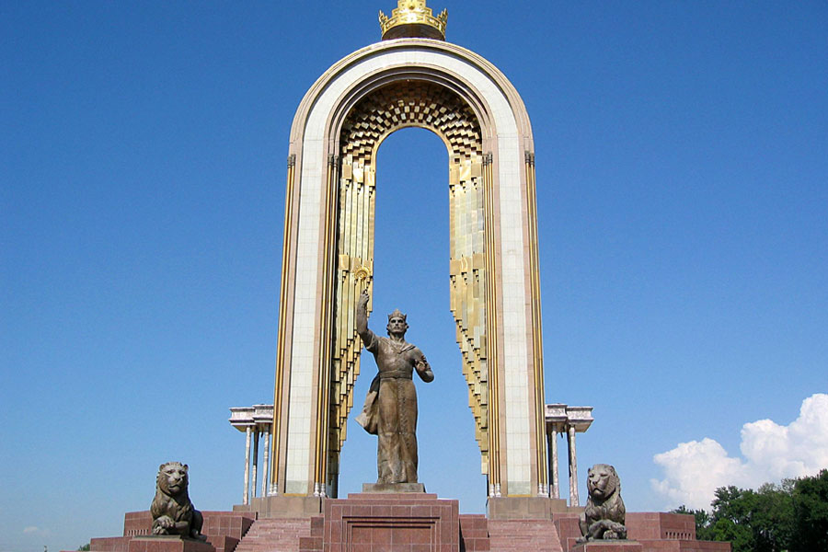
After a visit to the Botanical Gardens, our five to six-hour tour this morning will include:
- The National Museum of Antiquities of Tajikistan, which has a good collection of Tajikistan archaeological artefacts and houses Central Asia’s largest reclining Buddha of almost 13 m long. It was found in 92 pieces at excavations in Bokhtar. The museum was established in 1934 by the Tajik branch of the Academy of Sciences of the USSR in time for the country’s Exhibition of National Economic Achievement. Archaeological, ethnographic and geological collections range from the 4th millennium BC to the start of the 20th century and include archaeological exhibits of excavations at Sarazm, Ajina-Tepe, Tahti-Sangin and the cities of Khujand, Panjakent, Kurgan-Tyube, Istaravshan and Kulyab.
- A stroll along Rudaki Prospect will bring us to the main mosque of Dushanbe and the Ismail Somoni Monument.
Our lunch break will be near the Kokhi Navruz (Navruz Palace). Visit this palatial 40 000 m² cultural conference centre modelled on a traditional tea house (but it does not serve tea!). Its columns are ringed with 24 carat gold, it has marble halls and 6 500 m² of wood from 94 different species all artistically carved by 500 craftspeople. It was once called the biggest tea house in the world.

Friday 15 September: Dushanbe – Iskanderkul – Panjikent
Today we head for Panjikent (305 km, 6 to 7 hours) via the Iskanderkul lake (above) where we will have our lunch stop. In Panjikent we will book into the Panjikent Plaza Hotel for two nights.
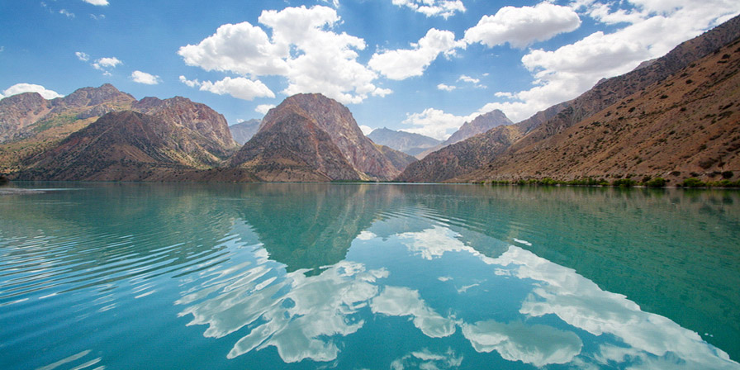
Saturday 16 September: Panjikent
Today there is a three to four-hour city tour in the company of a local archaeologist and English-speaking guide/translator to see the following:
Ruins of Penjikent (pictured below), a major Sogdian (early Persian) city captured in 722 AD during the Arab Conquest. Ancient Penjikent was a small but flourishing town on the Zervashan River known as Panchekanth. Many ruins of the old city, particularly the architecture and works of art, remain today (see tour notes).
Settlement of Sarazm, 15 km from Panjikant on the Zeravshan River near the border with Uzbekistan, where occupation is believed to have started in the first half of the 4th millennium BC. At the peak of occupation, the site would have covered an area of up to 90 ha. Sarazm is of great interest for archaeologists as it was the first proto-historical agricultural society in this region of Central Asia. It was also the first city in Central Asia to maintain economic relations with a network of settlements covering a vast territory from the Turkmenistan steppes and the Aral Sea to the Iranian Plateau and the Indus River (see tour notes).
The Rudaki Museum of History that offers an insight into the surrounding historical sites, especially the hilltop fortification. Artefacts detail life over a thousand years: a series of Sogdian frescos that show the hero Rustam doing battle with demons, burial jars, cooking pots, other pottery and very fine jewellery. Other sections focus on the poet Rudaki (859 to 941), who is said to be the founder of classical Persian poetry, the Samanid dynasty, local costumes and furniture, and the Russian Imperial and Soviet periods.
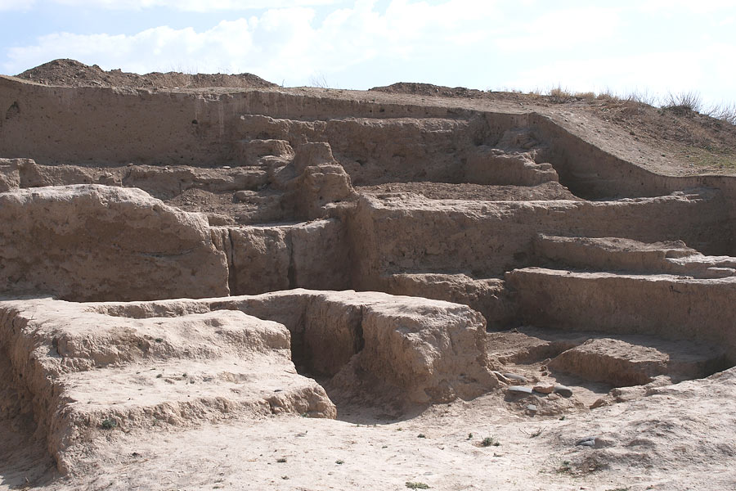
In the afternoon we transfer to the Tajikistan-Uzbekistan Jartepa border (20 km), where we meet our Uzbek guide and driver and transfer to Samarkand (60 km, 1 hour), one of Central Asia’s oldest cities dating from the mid-1st century BC. We check into the Grand Samarkand, Platan or Sultan Hotel.

Sunday 17 September: Panjikent – Samarkand, Uzbekistan
In the morning we meet our guide for a 3-to-4-hour tour of Samarkand to the following sights:
Registan Square: Surrounded by 15th to 17th century madrassah (Ulagh Beg – 1420, Tilya-Kori – 1660 and Shep-Dor – 1636) (right) with fluted turquoise domes and a mosque, this is one of the most breath-taking sights in Central Asia and a UNESCO World Heritage Site. In this square the people gathered to hear royal proclamations, heralded by blasts from enormous copper pipes called dzharchis, or to watch public executions. To the east of the Tilya-Kori Madrasah lies the 16th century mausoleum of the Shaybanids. In 1500, with the backing of the Chaghataite Khanate, then based in Tashkent, Muhammad Shaybani, a leader of nomadic Uzbeks, conquered Samarkand and Bukhara and toppled their Timurid rulers. He then turned on his benefactors and in quick succession took Tashkent, Khiva and Merv in Turkmenistan, as well as eastern Persia and western Afghanistan. The Shaybanids stopped the advance of the Safavids, who in 1502 had defeated the Akkoyunlu of Azerbaijan. During the ensuing years they settled down in the oases of Central Asia. The Uzbek invasion was the last component of today's Uzbek national ethnogeny.
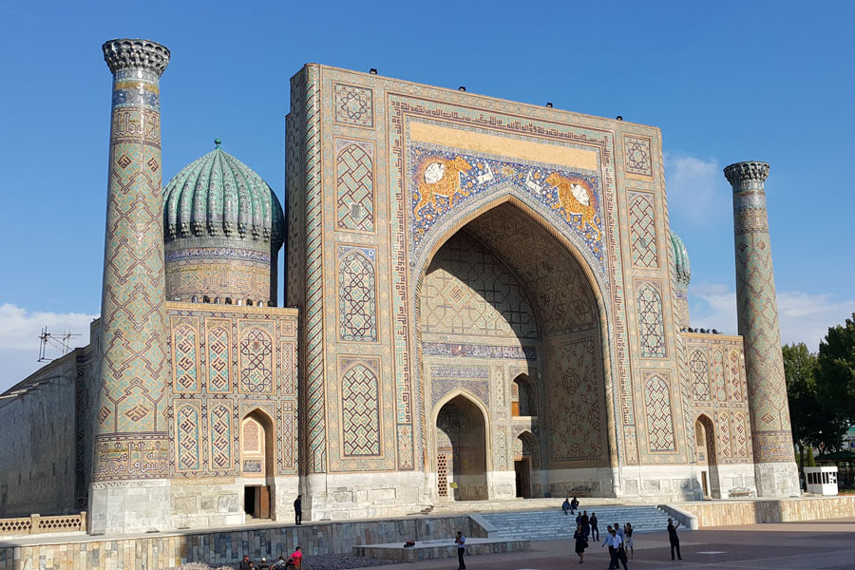
The Ulugh Beg Observatory, which was built in the 1420s by the Timurid mathematician and astronomer Ulugh Beg, who became a ruler of Samarkand. The observatory was destroyed in 1449 but over 60 mathematicians and astronomers visited the observatory. Part of the largest sextant of the time, constructed in marble, is preserved. The device was carefully oriented and the arc was scaled very accurately. Calculations of the positions of the sun, planets and thousands of stars enabled the determination of the duration of the year, the periods of planets and eclipses. Ulugh Beg’s measurements of planets closely relate to today’s measurements.
Afrasiyab is the oldest part of Samarkand. It was the centre of Sogdian culture from the 7th to 6th centuries BC to 1220 AD. Four layers of occupation are found in this mound. Excavations uncovered the now famous Afrasiab frescoes, which we see in the Afrasiab Museum (see tour notes).

The remainder of the day is at leisure.
Monday 18 September: Samarkand – Bukhara
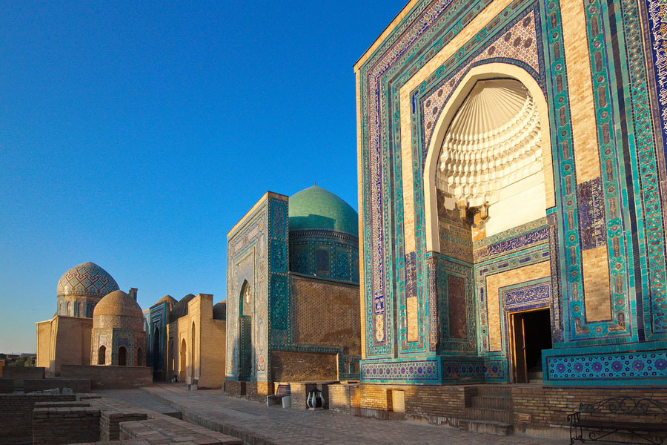
After checking out of our hotel, we continue our tour of ancient Samarkand (6 to 7 hours), visiting:
Shakhi-Zinda or ‘The Living King’ is a necropolis comprising around 20 mausoleums and other ritual buildings of 11th to 19th centuries. The name reflects the legend that Qutham ibn Abbas, a cousin of the Prophet Muhammad, is buried here. He is said to have come to Samarkand with the Arab invasion in the 7th century. Popular legend holds that he was beheaded for his faith but did not die but took his head and went into a deep well (‘Garden of Paradise’) where he is still living. The middle group of buildings comprise mausoleums of Timur's relatives and top military and clergy from the late 14th to first half of the 15th century.
Gur-i-Amir mausoleum, Timur’s ‘Tomb of the King’ where his throne from the Kok-Serai palace as well as the royal graves of his sons Shah Rukh and Miran Shah, grandsons Ulugh Beg and Muhammad Sultan and Timur's teacher Sayyid Baraka are situated.
The Siab Bazaar, with a tented trading area of 5 ha, is the largest bazaar in Samarkand and has a true oriental atmosphere. It is a dekhkan (agricultural) market where one mainly finds vegetables and fruits grown in Uzbekistan, dried fruits, nuts spices, sweets, more than 17 kinds of bread and hand-made products. Tasting before purchase and bargaining are a requirement.
Koni-Gil village. In the afternoon we drive out to this village to see the traditional way Samarkand paper is made from mulberries. The Meros paper mill in its picturesque setting has revived the ancient paper-making tradition following 10 years of experimentation. The raw material for the paper is mulberry bark, which is cleaned and boiled for a long while before being beaten into a homogeneous mash. The resulting ‘dough’ is filtered in a tub of water. A blank is pressed and is covered with the next sheet and some sifted mulberry brew. The paper is dried in a vertical position for a day. To remove the roughness of the paper, the master polishes it on a granite table with a piece of granite or bone horn. As it is unbleached, Samarkand paper has a characteristic yellow colour and a shelf life of up to 400 years. It is widely used for the restoration of ancient manuscripts. A small tea house at the entrance treats visitors with a delicious Samarkand pilaf and fruits.
On return to Samarkand there will be some free time before an early dinner. At 20:00, proceed to the railway station for the 21:03 ‘Afrosiyob’ express train (luggage will be forwarded by bus). A 90-minute journey will bring us to Bukhara (see tour notes), a Silk Route Persian city over 2 000 years old that is hailed by some as ‘one of the most romantic places on earth’. Transfer to the Minzifa, K Komil, Bibikhanum, Amulet or As-Salom Hotel, our hotel for two nights.

Tuesday 19 September: Bukhara – Paykent – Bukhara
08:00 Depart for Paykent (60 km) in the Kyzylkum Desert, a 4th century BC to 9th century town that was one of the largest cities of the Bukhara oasis (see tour notes). We will be accompanied by a local archaeologist and English-speaking guide/translator. After our tour of the site, we visit the History of the Paykent Settlement Museum, which houses artifacts from the area, such as tableware, ceramics, Chinese and Japanese porcelain, jewellery and coins dating from the 2nd to 9th centuries.
On return to Bukhara, we enjoy a guided walking tour in the Old City. The sites are close together.
Lyab-i Hauz Ensemble with a large water reservoir dating to 1620 and flanked by 16th and 17th century architecture. Until the Soviet period, there were many such pools that served as the city's principal source of water but they were notorious for spreading disease and were mostly filled in during the 1920s and 1930s. The Layb-i Hauz pool is the centrepiece of a magnificent architectural ensemble comprising the Kukeldash Madrasah (1569) with 160 cells, a lodging house for itinerant Sufis (1620) and the Khanqah (religious edifice) of Nadir Divan-Begi (1622) (see tour notes).
Maghoki Attori Mosque, ‘the mosque in a pit in the perfume market’, dates from the 12th century but was rebuilt in 1547. However, it is it is speculated that the original structure was built in the 9th or 10th centuries upon the remains of a Zoroastrian Temple of the Moon. The name refers to its floor lying about 45 m below the surface. Before the construction of the first synagogue, Jews shared this mosque with Muslims. Some say that Bukharian Jews and Muslims worshipped alongside each other at the same time, while other insist that Jews worshipped after Muslims. Until the Arab conquest the site was a bazaar for idols, potions, spices and perfumes. Today, the mosque is a carpet museum.
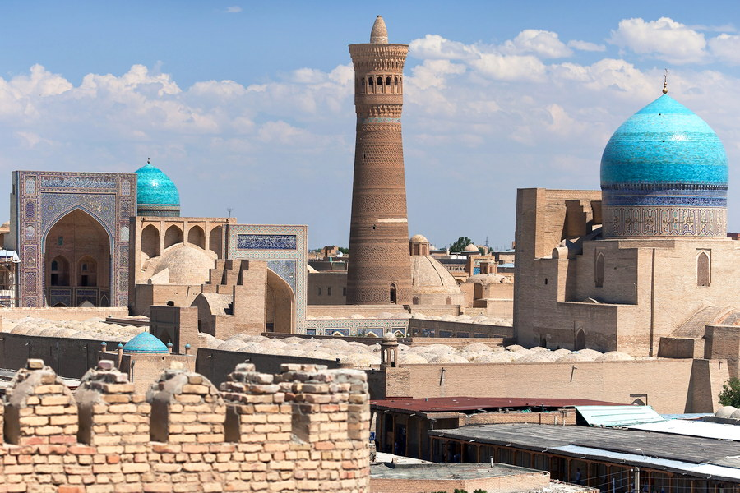
‘Toks’. We will visit one more of these 15th to 16th century trade domes that cover street intersections. The Tok-i-Sarrafon is the dome of the money changers, the Tok-i-Zargaron, the dome of the jewellers and the Tok-i-Tilpak-Furudshon, the dome of the hatters.
Poi-Kalyan ensemble, which comprises the 12th to 16th century Kalan Mosque, the Kalan Minaret and the Mir-i-Arab Madrasah, is one of the outstanding monuments of Bukhara. The mosque is the largest in Central Asia after Bibi Khanum in Samarkand and the Great Mosque of Herat in Afghanistan.
The Ark of Bukhara. This massive earthen fortress dates from the 5th century AD. It encompassed a town that during much of the fort's history was inhabited by various royal courts that held sway over the region surrounding Bukhara. As a fortress, the Ark served its purpose until it fell to the Soviets in 1920. Today the Ark houses museums on the city’s archaeology and history, the throne room, the reception and coronation court, and the court mosque (see tour notes).
Bolo-Hauz Mosque (1712) with its slim wooden pillars and an iwan stands opposite the Ark. The columns are decorated with coloured muqarnas.
Ismail Samanid Mausoleum, located just outside the historic centre, was built in the 10th century as the resting place of the powerful and influential Islamic Samanid dynasty that ruled from about 900 to 1000. It contains three graves, one of which is known to be that of Nasr II. The mausoleum is considered one of the iconic examples of early Islamic architecture. It is the oldest Muslim funerary building of Central Asian and the only surviving monument from the Samanid era (see tour notes).
Chashma-Ayub Mausoleum (1380). The name means Job's well. In legend, Job (Ayub) visited here and made a well by striking the ground with his staff. The current building was constructed during the reign of Timur and features a Khwarazm-style conical dome uncommon in Bukhara. It stands in the middle of an ancient cemetery.
Bukhara has nice small coffee shops and souvenir markets and is known for its carpets and knives.

Wednesday 20 September: Bukhara – Khiva
03:30 A very early departure for the railway station for the train to Khiva departing at 04:22. We arrive at Khiva (see tour notes) at 10:58. Transfer to the Muso Tura, Polvon Qori, Orient Star or New Star hotel for a two-night stay. The morning is at leisure.
13:00 We start our walking tour of Ichan Qala (photo below), visiting the following sights on foot in the company of a local archaeologist and English-speaking guide/translator. All sites are situated close together.
The Ichan-Kala Fortress retains more than 50 historic monuments and 250 houses dating primarily from the 18th and 19th centuries. The most spectacular features are the rectangular fortress’ crenelated brick walls and four gates. Although the fort’s foundations are believed to have been laid in the 10th century, today’s 10 m high walls were erected largely in the late 17th century.
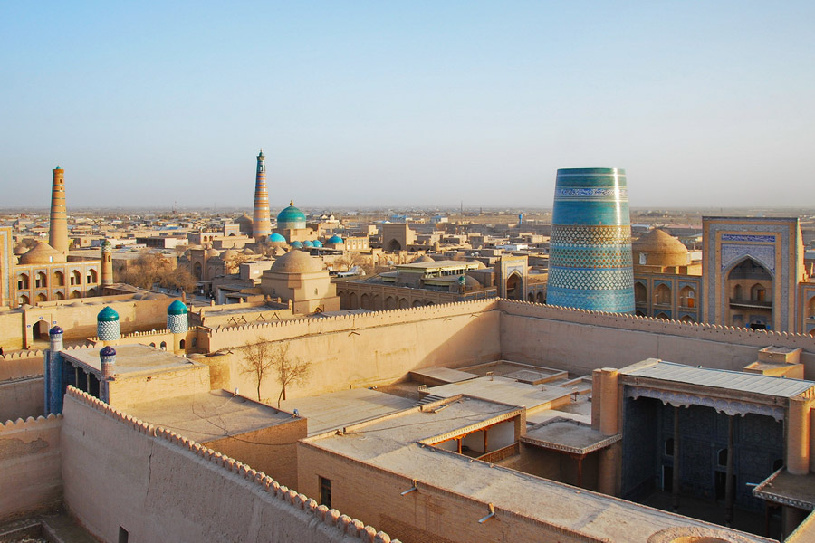
Mukhammad Amin Khan Madrasah is the largest madrasah in Central Asia. The two-storied building occupies has 125 khudjras (cells) to house 260 students. The madrasah was completed in 1854 by the order of Khiva ruler Muhammad Amin Khan. The building has five domes and flanking towers. The facade is decorated with rich ornament of glazed brick, the wooden doors are carved and the majolica face impresses with herbal patterns.
Mukhammad Rahim Khan Madrasah was completed in 1876. Rahim Khan II was an enlightened monarch who wrote poems under the nom-de-plume Firouz. During his reign, art and science prospered. New schools teaching both spiritual and secular subjects were opened. The layout of the madrasah is unusual: the main building with a huge entrance portal lies at the far end of a courtyard. The corners of the building have guldasta (bouquets) topped by small domes on drums decorated with mosaics. The avian canopy at the front door is decorated with curly brickwork. The facade has a rich decor of glazed brick, ornamental door carvings and striking majolica floral patterns.
The Kalta Minor Minaret was commissioned by Muhammad Amin Khan as an architectural marvel 70 m high but is unfinished. The Khan's death on a Persian battlefield in 1855 put an end to the project when the minaret had reached a mere 26 m. Even in unfinished form the structure is dazzling, covered from top to bottom with Khiva's signature blue-green tiles in various geometric patterns. It is the only minaret in Central Asia to be fully sheathed in glazed brick and majolica.

Thursday 21 September: Khiva
We continue our tour of Ichan Qala on foot.
Juma Mosque at the centre of Itchan Qala was first documented in the 10th century but rebuilt in 1788. It was designed to house many congregants and rather than having a typical open-air courtyard, it has a 55 m by 46 m prayer hall with 213 black elm columns in 17 rows. Except for two small lightwells and small entrances, there are no windows, creating a dim and secluded atmosphere that even today is a welcome respite from the unrelenting Khivan sun. It has a 33 m tall minaret.
Tash-Khauli Palace (1838) is an example of Khorezm architectural grandeur. It was built by order of Allakuli-Khan who wanted it erected in two years, but it took four times as long, which cost many master-builders their heads. The khan’s room is the largest and richly decorated. Four other rooms were used by the khan’s wives, while a two-storey structure provided accommodation for female relatives and concubines. The walls are richly decorated with white and blue majolica panels, the ceilings are painted brown and red, and the windows have fancy copper grates. No part of the decoration is repeated. A square yard with a central round platform for the khan’s yurt was designated for guests and delegations. Terraces and rooms are all splendidly decorated with traditional white and blue majolica, a Chorasmian decorative technique revived by craftsmen.
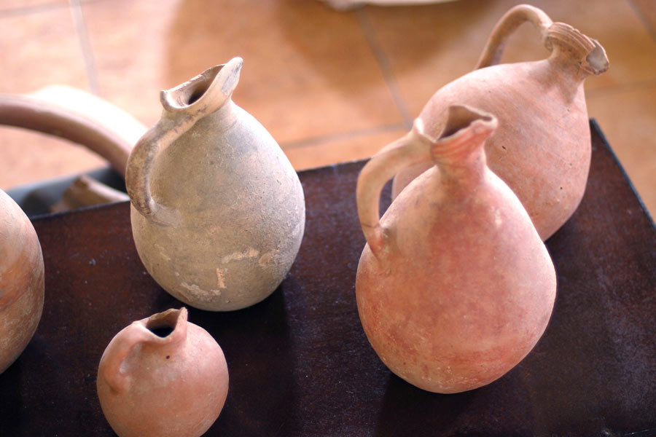
Pahlavan Mamud Mausoleum (1810 and 1825). Mamud (d. 1320) was a celebrated poet, philosopher, legendary wrestler and an extraordinary compassionate man who became Khiva’s patron saint. He authored more than 300 rubai in which he described life with all its joys and sorrows. The Persian-style building is an architectural gem. Turquoise tiles decorate the largest dome of Khiva and all its rooms are faced with majolica.
Islam-Khoja Minaret, the highest in Uzbekistan.
Following a lunch (included) the afternoon is free for shopping. Items like exquisite textiles, coral jewellery and antiques are a Kiva speciality. Dinner for own account.
Friday 22 September: Khiva – Nukus Check out of hotel and drive 200 km (4‒5 hours) north-west to Nukus in Karakalpakstan. En route
we visit Toprak-Kala, the capital of Khorezm in the 2nd to 3rd centuries AD. Called ‘the museum of fine arts of Khorezm’, it is the only completely excavated Khorezm site. Its size and genius make it a most unique monument (see tour notes). We will also visit Chilpyk, a Zoroastrian dakhma, a round, roofless funerary tower. On arrival in Nukus, we check into the Jipek Joli Hotel for two nights before visiting the following sites accompanied by a local archaeologist:
Ayaz Qala fortress is situated on the colourful cliffs of one the Sultauizdag eastern spurs overlooking the Kyzylkum Desert. Built between the 4th century BC and the 7th century AD, it was one of the largest fortresses of Khorezm. Legend associates the name of the fortress with the semi-mythical hero warrior-slave Ayaz, a Turkic folklore hero, who is said to have the thrown himself at an Amazon princess who lived in the Kirk-Kiz fortress. Archaeologists hold that the Ayaz Qala fortress belongs to the 2nd century AD, the heyday of the Kushan Empire, and was part of a system of forts protecting the oasis from the desert.
Shylpyk-Kala is a more than 2 200-year-old Zoroastrian dakhma or funeral tower, 15 m high and 65 m in diameter, located at the top of a hill 43 km from Nukus. As Zoroastrian philosophy prohibited the defiling of the land with corrupted bodies, the remains of the deceased were placed in the tower to be consumed by birds of prey. Later the bones were collected in an ossuary for burial. The tower was rebuilt following the arrival of the Arabs in the 8th century and again during the heyday of Khorezm. Shylpyk-Kala is depicted on the coat of arms of Uzbekistan. The hill offers an excellent view of the surroundings, including the Amu Darya River.
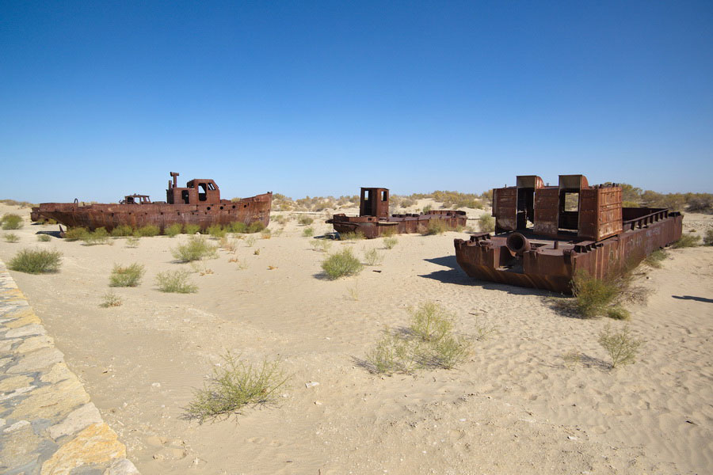
Saturday 23 September: Nukus – Muynak (Aral Desert) – Nukus
This morning we will visit the Savitsky Karakalpakstan Art Museum, which hosts the world’s second largest collection of Russian avant-garde art, as well as Karakalpak folk art. The museum has been described by The Guardian as the ‘Louvre of Uzbekistan’ (see tour notes).
Then proceed to the area of one of our planet’s worst environmental disasters. On the way to the former fisherman’s town of Muynak (220 km, 3 hours), stop at the archaeological complex of Mizdakhan, once the second-largest city in Khorezm after Konye Urgench. Established in the 4th century BC, it was inhabited for about 1 700 years. A local legend says it is the burial site of Adam (see tour notes).
Muynak once lay on the shores of the Aral Sea (see tour notes) at a time when it was still the fourth largest lake in the world with an area of 68 000 km². The Aral Sea had largely dried up by the 2010s owing to Soviet intervention. Today it has been renamed the Aral Desert. In Muynak we visit the former port with its abandoned ships lying on the sand – also known as the ‘Cemetery of Ships’. At the local history museum see exhibits on the history of the Aral Sea. Return to Nukus.

Sunday 24 September: Nukus – Tashkent – Almaty
07:30 After an early breakfast, transfer to the airport
09:30 Depart Nukus for Tashkent on Uzbekistan Airways flight 12, arriving at 10:50
14:35 Depart Tashkent for Almaty on Air Astana KC128, arriving at 17:05
Transfer to the Navruz, Ateca or Praga Hotel for overnight

Monday 25 September: Almaty - Doha – Johannesburg
02:00 Transfer to airport
04:25 Depart for Doha on Qatar Airways flight QR0390, arriving at 06:15
07:30 Depart for Johannesburg on Qatar Airways on flight QR1367, arriving at 14:55. End of tour.

TOUR PRICE

Per person sharing: R89 500 plus US$200*
Single supplement: R10 500 per person

** The US$200 price component per person will be collected at various times during the tour to cover the gratuities of the Central Asian tour manager, national guides, archaeologists and drivers, and out-of-pocket payments made for the group by the tour leader.

Included in the tour price
All tour arrangements as per the itinerary, including economy-class airfares from Johannesburg return and within Central Asia (tax components are subject to change and could affect the final tour price); surface transportation in air-conditioned 40-seater coaches; return trip from the Fergana Valley by sedan cars (three passengers per car); business class rail tickets for the Tashkent-Margilan and Samarkand-Bukhara sections; accommodation in the hotels indicated based on the sharing of double/twin rooms (or single rooms where the single supplement has been included); all rooms with en suite facilities and air-conditioning; free Wi-Fi at hotels; all breakfasts at hotels; all dinners at local restaurants except where picnic lunches replace dinners; 1 ℓ of mineral water per person/day; the services of a tour leader from South Africa; the services of a professional, English-speaking Central Asian tour manager; a national English-speaking guides in each country; local archaeologists at archaeological sites as indicated; entrance fees to all sites listed in the itinerary; tips to hotels and restaurants; and gratuities and tips to the tour manager, local guides, archaeologists and driver; visa support letter for the Kazakhstan tourist visa.

Not included in price
All lunches except when indicated otherwise; personal expenses (laundry, room service, beverages); any optional visits and entertainment; porter services at airports and hotels; travel insurance (see ‘Important Information’); visa costs (see ‘Important Information’); and add-on fares from other centres in South Africa. Passengers joining from elsewhere in the world will receive a credit against the tour price for the Johannesburg – Doha – Almaty – Doha – Johannesburg flights and will book and purchase their own flight tickets to Almaty return.

IMPORTANT INFORMATION
Tour organiser and leader: Reinoud Boers, 5 Henry Road, Rivonia, Sandton; PO Box 2196, Rivonia, 2128; tel. 011 803 2681; cell: 082 566 6295; fox@boers.org.za.
Central Asia tour operator: Ms Sevara Fayzieva, Advantour, +998 78 150 3220 (office) and cell +998 90 324 7183.
Emergency contacting during tour: The most convenient way to contact you during the tour is via the Central Asian tour operator.
Tour conditions and terms: Please refer to the Tour Booking Form.
Conditions on tour: Standards and conditions in Central Asia can be different from what Westerners are used to. Some of the roads we will be travelling on may be torturous.
Transport: Air-conditioned 40-seater coaches and by rail. The tour to Tamgaly in Kazakhstan is by mini-buses and from Fergana we will return to Tashkent by car (three persons per car).
Accommodation: Hotels mainly have a 3-star rating, but some are of 4 and 5-star standard. Often hotels are lovely boutique hotels with traditional decor. All hotels are well situated. In some hotels rooms with double beds may not be available, in which case twin-bedded rooms will be provided. Meals: All breakfasts at hotels. Dinners at local restaurants. In a couple of instances, picnic lunches will be provided instead of dinners, in which case dinners are for own account. Lunchbreaks will provide time for refreshments and the purchase lunch snacks.
South African tour leader and regional tour manager: The tour will be accompanied throughout by a tour leader from South Africa and a professional English-speaking regional tour manager.
National tour guides: In each country a professional, registered, English-speaking guide will accompany us on all sightseeing.
Archaeological experts: At selected archaeological sites, as indicated in the itinerary, we will be accompanied by a local archaeologist and an English-speaking guide/translator.
Climate: Central Asia has a continental arid and semi-arid climate with hot, cloudless, dry summers.
Almaty, Kazakhstan: Warm, dry, mostly clear. Temperatures: max. 25 °C, min. 13 °C.
Tajikistan: Hot, sunny and dry. Temperatures: max. 30 °C, min. 12 °C.
Uzbekistan: Hot, sunny and dry. Temperartures: max. 30 °C, min. 12 °C.
Reading suggestions for Central Asia: A list of recommended books for ordering will be sent to participants.
Passports: Passports must have a validity of at least six months and have at least two empty pages.
Visas: Further information will be provided:
Kazakhstan: South African passport holders must apply for a single-entry e-visa at www.vmp.gov.kz. A letter of Invitation, provided by our ground operator, must accompany the application. The e-visa fee is around US$50.
Uzbekistan: South Africans passport holders must apply for a double-entry e-visa three months before departure at https://e-visa.gov.uz/main. The e-visa fee is US$30.
Tajikistan: South African passport holders must apply for a single-entry e-visa three months before departure at www.evisa.tj. The e-visa fee is US$50.
Travel insurance: Travel insurance is a requirement for all. Unless proof of satisfactory international travel insurance can be supplied, travel insurance (group, senior or super-senior, as applicable) arranged by ArchFox Tours will need to be taken out. Further details will be provided.
Health precautions: No special inoculations are required but ensure your travel vaccinations are up to date as regards hepatitis A, hepatitis B, typhoid, tetanus and rabies, and bring along your International Health Certificate (yellow booklet).
Water: Only bottled mineral water should be drunk in Central Asia. A 1 ℓ bottle of water per participant per day is included in the tour arrangements.
Diarrhoea: Take care with the water you drink and the food you eat. Bring along medicine, such as a diarrhoea antibiotic and rehydration medication.
Clothing: You can pretty much wear what you want in Central Asia, but what you wear determines first impressions and how you are received. Dress comfortably and informally. Dress at dinner is generally ‘smart casual’ but you may want to bring a dress or jacket for the better restaurants. Take light cotton clothing but allow for cooler weather, especially in the evenings. Comfortable but sturdy, closed shoes with rough soles are advisable.
Clothing and behaviour mosques: Wear modest, conservative clothing. Shorts, T-shirt and sleeveless tops are not recommended. Slacks and shirts for men and knee-length dresses or skirts and blouses that cover the shoulders, and a headscarf are suggested. Inside mosques, please speak quietly, move slowly, avoid walking in front of worshipper performing their prayers and do not use a flash for photos.
Local dress custom: Islam is the dominant religion in Central Asian. In Uzbekistan and Tajikistan men wear baggy pants caught in at the ankles with tunics, turbans or hats, whilst women wear dresses that are generally full-sleeved and fall to below the knees. A head scarf tied at the back of the neck is traditionally worn over the head.
Things to consider bringing along: Sunhat, sunblock, sunglasses, wet wipes, toilet paper, hand sanitiser, torch and batteries, personal medication, eye drops, insect repellent, toiletries, swimwear and a bathing cap, adapters, binoculars, photographic equipment with adequate SD-card capacity, and an umbrella for the unlikely event of rain. A money belt is always useful.
Luggage: Keep luggage compact for your own comfort. Use travel locks and affix address details to the inside of luggage. A daypack could come in handy for carrying water etc. during sightseeing.
Currency and exchange rates: Exchange rates on 20/01/2023 were as follows:
Kazakhstan: Currency Kazakhstani Tenge (Kz). 1 Kz = 0.0022 US$ or 0.037 ZAR.
Uzbekistan: Currency Uzbekistani Som (So’m). 1 So’m = 0.000089 US$ or 0.0015 ZAR.
Tajikistan: Currency Tajikistani Somani (SM). 1 SM = 0.098 US$ and 1.69 ZAR.
Changing money: It is recommended that you bring at least part of you spending money in US dollars or Euros cash for exchange to local currencies at money offices at hotels (open from 08:00 till 18:00, but sometimes 24 hours. Hotels front desks and airport money exchanges are not recommended as they may provide a poor exchange rate, and banks take up too much time (09:00 to 16:00 Monday to Friday; possibly closed at lunchtimes). Banks charge a 2% to 4% service charge for withdrawals. In Kazakhstan and Uzbekistan, but not in Tajikistan, local currency can be easily changed back to USD or Euros. Exchange offices and banks do not accept banknotes issued earlier than 1996, or worn out, torn, lined or wrinkled notes or notes that have been written on.
ATMs are not widespread in Central Asia but selected banks and upmarket hotels may have Visa and Mastercard ATMs that dispense local currency. ATMs generally offer the best exchange rates.
Credit card payments: Visa and Mastercard credit cards are not widely accepted outside of large hotels and upmarket restaurants in the main cities of Uzbekistan and Tajikistan. Shops and restaurants prefer to be paid in local currency.
Time changes from Johannesburg: Almaty: +4 hours; Uzbekistan and Tajikistan: +3 hours
Cell phones and charges: Cell phones operate throughout Central Asia but calls costs will be high. Beware of exorbitant hotel call rates. Use WhatsApp or Skype, or reverse calls. Local Simcards are available for purchase at the airport or shops (take your passport).
Electricity: Electricity supply in Central Asia is 220V, 50HZ, and the round-prong European-style plug fitting into recessed wall sockets as shown alongside is used. Most hotels have both 110V and 220V electrical outlets in the bathrooms.

Tipping: Tipping for good service is appreciated. On the drinks you order or should you have lunch or dinner ( service fee of 15 to 20 per cent is usually included in the bill) on your own, the suggested rate for tipping is 3 to 5 per cent.
Photography: Throughout the tour take care not to photograph or video anything of a police or military nature, e.g. bases, buildings, vehicles, aircraft and personnel. It is best to check first when taking shots of cultural and religious ceremonies. Please ask when you wish to photograph people close up. Also note that some museums and sites may require payment of a photo/video fee.
Safety: You will find the Central Asian people friendly and hospitable. The region is safe to travel in and most people are honest and trustworthy. But no country is immune to crime, weather can affect travel plans and accidents do happen. There are currently no health threats to tourist. Follow your tour manager’s and/or guides’ advice and safety instructions. Petty crime does occur and tourists are particularly vulnerable. Note the following:
- Use common sense, particularly around tourist areas and crowded places like markets.
- Guard against pickpockets and bag-snatchers; hold your bag close.
- Keep wallets, mobile phones, cameras and jewellery out of sight as far as possible.
- Make especially sure to protect your passport, air tickets and visa documents.
- Never leave valuables lying around your hotel room.
- Carry a photocopy of your passport and other vital documents separately.
Duty free allowances:
Kazakhstan: 200 cigarettes or 50 cigars or 200 g tobacco; 3L alcohol; perfumes for personal use
Tajikistan: As above but only 2L alcohol
Uzbekistan: 10 packs of tobacco products; 2L alcohol; 3 bottles of perfume or eau de toilette
Limitations on international flights: In hand-carried luggage, the containers of liquids, aerosols, gels, perfumes and deodorants, creams, balms, lotions, oils, mascara, lip gloss, toothpaste, pressurised foams, sprays, hair and shower gels, contact lens solution and similar items may not exceed 100 ml. Medication and prescription medicines are excluded but must be placed in a transparent resealable plastic bag and be presented sealed for examination at the security screening point.

