REGISTRATION FORM

To register, please complete this form and submit it with your proof of payment. REGISTRATION FEES ARE PAYABLE IN ADVANCE.
• E-mail all details to anner@mweb.co.za
• Post to: PO Box 41050, Craighall, 2024
Names of attendees: (Title, first and surname)
Member:
____________________________________________ Yes / No

____________________________________________ Yes / No

____________________________________________ Yes / No

____________________________________________ Yes / No

Email address: ________________________________________

Phone: ______________________________________________
(home and cell)

Fees payable: Please pay by EFT if possible Total
Members @ R230 pp | R
Non-members @ R300 pp | R
Students @ R70 pp | R
If depositing CASH or CHEQUE please add R50 pp to  cover Bank charges | R
Total amount due | R

FEES ARE PAYABLE IN ADVANCE
SA Archaeological Society, Standard Bank, Rosebank
Branch code: 004305, Account no: 001945920
INCLUDE YOUR NAME AND THE REFERENCE ‘SYMPOSIUM’ ON THE DEPOSIT SLIP.

E-mail proof of payment with your registration form to Anne Raeburn at anner@mweb.co.za If you wish to check on your booking, please phone Anne Raeburn on or after 22 August on 072 349 6507 Monday to Friday during Business Hours.

ANNUAL SYMPOSIUM

Climate change: episodes in the history of the earth

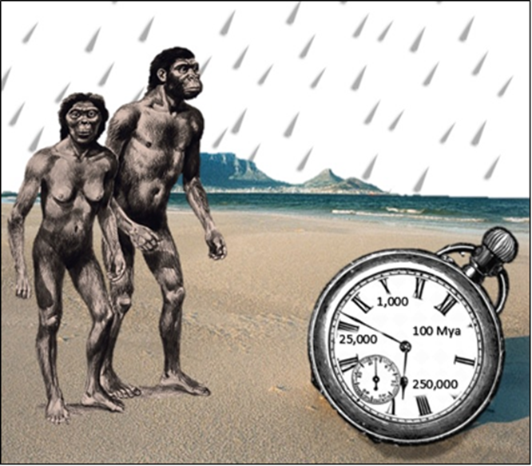

Saturday 24 August 2019

South African Archaeological Society
Northern Branch

Registration: 9:00 – 9:30
Venue: Delta Environment Centre, Delta Park, Road No. 3, Victory Park, Johannesburg.

Parking: Secure parking at the Centre.

Fees: Please note that the student fee is only applicable to full-time students, please supply student number.

Catering: Bring your own picnic lunch to enjoy at the tables or on the lawns. The price of a glass of wine or fruit juice is included in the registration fee. Tea, coffee and biscuits will be served mid-morning and after the last lecture.

Book Table: A wide selection of new and second-hand books will be available for purchasing before the symposium starts, at the morning tea break, the lunch period and at the end of the symposium during the afternoon tea break.

The Northern Branch’s Annual Symposium is designed to bring academics and society members together once a year for a day of fascinating lectures.
These days we often hear about how the climate is changing, the seas are rising, the ice caps are melting. We seem to see far more on the news channels about severe hurricanes, flooding, forest fires, droughts, and extinctions of species, be they of land animals, marine animals, or plants. At a human and animal level we have starvations due to climate change. Yet we have politicians who deny the very existence of global warming or more correctly climate change.

The 2019 annual symposium looks back over time at some of the climate-related mega-events that have helped to form the world that we now live in. We move from the extinctions of Triassic times to the earlier and middle stone ages, and how early humans coped in glacial and inter-glacial times. Then to humans and climate change in the later stone age, and, more recently, in the last 1000 years. A world that we are poisoning with our modern use of plastic and carbon emissions.

These talks will focus on the impact of past climate changes on life on earth. We will close with a look into our possible future.

PROGRAMME: Saturday, 24 August 2019

The other "Big Five": Lessons about climate change from Earth's previous mass extinctions

Prof Jonah Choiniere is Professor of Palaeontology at the Evolutionary Studies Institute of the University of the Witwatersrand, He completed his PhD at the George Washington University in 2010, and worked for two years at the American Museum of Natural History in New York City before moving to Johannesburg. His research is on the rise of South African dinosaurs after the Triassic mass extinction.

‘Palaeoclimatology and hominid evolution 100mya.’ 'Vegetation, palaeoclimate and hominid evolution.’

Prof Marion Bamford obtained her PhD in Palaeobotany from the University of the Witwatersrand in 1990. She is the Director of the Evolutionary Studies Institute (formerly the Bernard Price Institute) where she supervises postgraduate students and lectures in Palaeobotany. Her main research interest is fossil wood but she also studies fossil leaves, seeds, pollen, phytoliths and charcoal and uses them to reconstruct the past vegetation and interpret the past climate.

“Climate change and its effect on people in the Middle Stone Age, 250 000 – 25 000ya.”

Prof Lyn Wadley is based in the Evolutionary Studies Institute at Wits where she specializes in Middle Stone Age cognitive archaeology. She is an A1-rated National Research Foundation researcher. In 2014 and 2015 she was on the Thomson-Reuters High Citation list that records the top 1% of researchers globally.

‘A climatic optimum? The late Quaternary climates of the post-Last Glacial Maximum’
Dr Jennifer Fitchett is a Senior Lecturer in Physical Geography at the School of Geography, Archaeology and Environmental Studies at the University of the Witwatersrand. Her primary research focus is on climate change, and the impacts on the human and natural environment, spanning decades to tens of thousands of years. She completed her PhD in 2015 as part of a split site programme between Wits and University College London.

‘Climate change in southern Africa over the last 1000 years’

Prof Stephan Woodborne is the Senior Accelerator Mass Spectrometry Scientist at iThemba LABS (Laboratory for accelerator based sciences). He obtained a PhD. in archaeology from the University of Cape Town in 1996. He is Associate Professor at the Mammal Research Institute at the University of Pretoria, Associate Professor in the School of Life Sciences at the University of KwaZulu Natal, and a research associate at the University of the Witwatersrand.

'Climate change today what future for agriculture?

Dr Kelsey Glennon is an evolutionary biologist interested in processes that generate new species. Her research involves fieldwork in the Drakensberg, genetics, and greenhouse experiments. She obtained a BSc in Biology from Salisbury University in Maryland, USA in 2005, and went on to finish her PhD in 2010 at the George Washington University.

