SOUTH AFRICAN ARCHAEOLOGICAL SOCIETY

A SWEEP THROUGH ANCIENT TÜRKIYE –
THE AEGEAN COAST AND THE SOUTH-EAST

1 to 16 June 2027

A 16-day tour with 15 days in Turkey

The 2027 South African Archaeological Society’s international tour will head to Türkiye once again. The archaeology and antiquities to be found in this country are amazing. Previously, in 2016, we travelled from Konya in the south all the way east along the Syrian border to Kars in the northwest, while in 2022 we toured central Anatolia, Türkiye’s Black Sea coast and Georgia. This time, in spring, we will visit another important region: the Aegean coast from Istanbul to Ephesus, an area of great Hellenistic, Roman and Turkish importance. After a Bosporus cruise and a tour of the 700 000 m² Topkapi Palace (1478) in Istanbul, we will cross the Dardanelles Straight to famous Troy (3600 BC to 500 AD) and continue to Pergamon (800 BC to 14th century AD); Selcuk – ancient Ephesus; Ephesus (10th century BC to 263 AD) and Aphrodisias (3rd century BC to 7th Century AD).
But the tour will not only cover the Aegean. After seeing Laodicea on the Lycus and Hierapolis in Pamukkale, Burdur and Sagalassos, we will turn east and travel through the lake district along the Taurus Mountains to Konya, Cappadocia, Gaziantep and Sanliurfa. On the way we will visit ancient archaeological sites such as Çatalhöyük – one of earliest villages in the world (6300-5500 BC; Aşıklı Höyük (8200-7400 BC); the Göreme Open-air Museum; the huge underground city of Derinkuyu; Eski Gümüşler Monastery; the Neo-Hittite capital of Tuwana; Karatepe-Aslantaş Open-air Museum (8th century BC); the fabulous Zeugma Mosaics Museum; the 2nd to 3rd century city of Zeugma on the Euphrates River; Carchemish on the frontier between Turkey and Syria where Nebuchadnezzar, King of Babylon, defeated Necho, king of Egypt in 605 BC; the Sanliurfa Archaeological Museum – Türkiye’s largest with a breathtaking display of objects from Göbeklitepe. In 2016, this 11 500-year-old hunter-gather-built spiritual complex comprised one astounding site; today 12 such sites are being excavated, three of whom we will visit. This will be a true highlight.
This stunning tour covers a period of civilisation from 9 500 BC to the 15th century AD and provides a true weep through the fascinating history of what we know today as Türkiye.

Tour manager: Reinoud Boers +27 82 566 6295
National Tour Guide:
Driver:
TOUR PROGRAMME

TUESDAY 1 JUNE: JOHANNESBURG – ISTANBUL
15:00 Participants meet at the Turkish Airlines check-in area at OR Tambo International Airport for the luggage tagging and check-in procedure.
17:50 Depart on flight TK 39 for Istanbul, Türkiye.

WEDNESDAY 2 JUNE: ISTANBUL – FREE TIME – BOSPHORUS CRUISE
14:30 Arrive at the International Istanbul Airport. We are met and transfer to the Armada Hotel or similar for two nights (www. armadahotel.com.tr/ default en.asp). Our hotel will be at the heart of the old city on the European side of Istanbul.
The morning is at leisure. If you don’t wish to catch up on sleep, visit nearby sights independently. The ancient Hippodrome, Byzantine Basilica Cistern, Blue Mosque and the Hagia Sophia will be beckoning.
After refreshments, we walk down to Eminönü to board a private boat for a fabulous three-hour Bosphorus cruise. Travel north past Dolmabahçe Palace, Çırağan Palace, Ortaköy Mosque, the 15 July Martyrs Bridge, Beylerbeyi Palace, Rumeli Fortress and the Fatih Sultan Mehmet Bridge before sailing back. Enjoy a ‘front-door’ view of castles, palaces and Yalis (a mansion built right on the water). Dinner will be at a restaurant in the old city.

THURSDAY 3 JUNE: TOPKAPI PALAC – SÜLEYMANIYE MOSQUE
In the morning we walk to the 700 000 m² Topkapi Palace Museum on a headland at the mouth of the Bosphorus. The palace was built by Sultan Mehmed II during the years 1460 to 1478 following the conquest of Istanbul. Extensions were made over the centuries. The palace remained the sultan’s main residence and centre of government until the mid-19th century. Topkapi Palace is one of the city’s most iconic buildings. In 1924 it became the first museum to be established in the Republican period. Today the palace and its grounds cover an area of nearly 350 000 m. The palace is composed of four sections: the Bîrun or Outer Palace, consisting of service buildings and guard posts; the Dîvân-ı Hümâyun or State Council building; the Enderûn or Palace School; and the Harem, the sultan’s private home.
In the afternoon, after refreshments (for own account), we will take a tram to the Süleymaniye Mosque, one of the most important examples of classical Ottoman architecture with great views of Istanbul. It was built between 1551 and 1558 by Suleiman the Magnificent. The dome of the mosque, which has four minarets, is 53 m high and the interior is 59 m long and 58 m wide. It has a main dome, two semi-domes and two quarter domes, as well as ten smaller domes. The main dome has four elephant feet. Sixty-four cubes 50 cm in length placed inside the dome and at the corners create excellent acoustics. Four large granite columns in the mosque were taken from Alexandria, Baalbek, Kıztaşı and Saray-ı Amire. We return by tram to our hotel. Dinner at a restaurant in the old city.
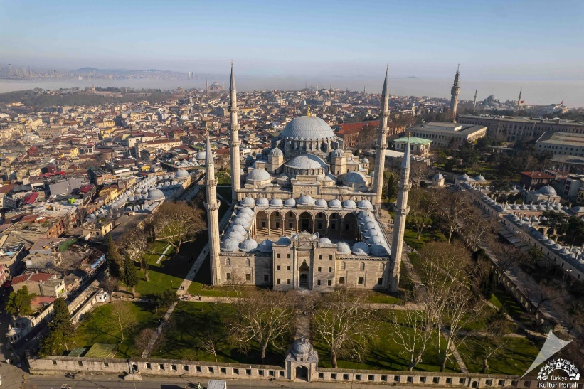
FRIDAY 4 JUNE: DARDANELLES - TROY AND ITS MUSEUM
Today we travel to the Troad in north-west Türkiye. By public ferry, we cross the Dardanelles Strait to Çanakkale and reach Troy 45 minutes later. Charles MacLaren and Frank Calvert were the first to link a hill containing ancient remains with the site of Troy, but the real breakthrough came in 1870, when the self-taught archaeologist Heinrich Schliemann travelled to Anatolia to uncover the city and prove that the Iliad was based on fact. Since then, Troy has been the subject of extensive excavation and study. The site was first settled around 3600 BC and over 4 000 years of existence, nine layers of occupation were deposited. From 1750–1180 BC, the city was by far the most important settlement in the area and history builds up a feasible background for a Trojan War. Troy fell into ruin around thereafter, but the site was never completely abandoned. The Troy or Ilion of the Greek and Roman periods again flourished until the end of the ancient world in the 6th century AD. After our fascinating site visit, we will go to the Museum of Troy, which received the 2020 European Museum of the Year Special Appreciation Award.
Continue to Assos. With its stunning deep-blue sea and sunset views, this is one of the most idyllic corners of the north Aegean. Facing the island of Lesbos, this ancient city is famous for its agora, theatre, sarcophagi and the Athena Temple. Aristotle also founded a philosophy school here. We overnight at the Assos Behram Hotel (1 night) www.assosbehramhotel.com Dinner will be at a local restaurant.

SATURDAY 5 JUNE: PERGAMON – ASKLEPION – EPHESUS MUSEUM
We drive to Bergama where, perched on top of a windswept mountain overlooking the azure Aegean Sea, lie the ruins of ancient Pergamon. Although the greatest part of its superb intact monuments now rest in Berlin’s Pergamon Museum, enough remains of the acropolis for the visitor to sense the former greatness of a city that once rivalled Alexandria, Ephesus and Antioch. A strategic location along both land and sea trading routes contributed to its prosperity. Pergamon rose to prominence during the years of the Greek empire’s division following the death of Alexander the Great in 323 BC. General Lysimachus inherited the settlement and also because of the wealth of the Attalid kings, the city enjoyed centuries of prosperity that continued when it passed peacefully to Rome’s control in 133 BC. In the 2nd century AD, pilgrims from all over the Mediterranean flocked there to visit the Asklepion, a centre for medical treatment where the eminent physician Galen (c. 129-200 AD) held sway.
The oldest and arguably most beautiful section of Pergamon’s acropolis, which we reach by cable car, rises triumphantly over the city’s ruins that cascades down the steep slopes to the valley below. One of the most dramatic structures of the acropolis was what scholars believe to be the Temple of Zeus, represented by massive foundations. Nearby is the site of the Great Altar of Pergamon, one of the most magnificent surviving structures from the Greco-Roman world, where one encounters the remains of the late 4th century Temple of Athena.
Just beyond, lies the magnificent structure that was the city’s famous library that housed at least 200 000 scrolls, one of the largest collections of written material in the ancient world. The best-preserved ancient sacred structure of Pergamum is the Temple of Trajan, built during the reign of Emperor Hadrian (117–138 AD). Considering its size, it is hard to imagine that this was one of the smaller sacred structures in the temple precinct. The nearly intact theatre provides one of the most spectacular settings of the ancient world. Cascading sharply down the precipitous slope of the acropolis toward the sea, the 80 rows of seating for 10 000 spectators are among the steepest of its kind. It is an acoustic marvel.
We next travel some 178 kms to Selcuk, ancient Ephesus, stopping at Şirince (the name means ‘cute’ in Turkish), a lovely place that is perhaps the perfect synthesis of traditional Turkish and Greek villages. After refreshments, a short drive up Ayasuluk Hill takes us to the ruins of the Basilica of St John, constructed by Emperor Justinian in the 6th century. It is believed that it stands on the burial site of the Apostle John, who conveyed messages to Christian congregations in Asia Minor. The hill is the perfect place from which to examine the topography of Ephesus. Our way up the hill takes us through the Gate of Persecution and the site of the Temple of Artemis which was one of the Seven Wonders of the Ancient World. Little remains of the temple today.
Our last visit of the day is the Ephesus Archaeological Museum in Selcuk. The works of art dug up from 1867 to 1905 in Ephesus were taken to the British Museum, those from 1905–1923 to Vienna. The Turkish Republic then banned the export of antiques and founded the museum. Its artefacts are presented by theme rather than chronologically. Highlights include two colossal statues of the Ephesian Artemis with their rows of bull testicles, symbolically related to the idea of fertility.
We overnight at the Kalehan Hotel for one night (https://hotelkalehan.com). Dinner will be enjoyed at the hotel restaurant.

SUNDAY 6 JUNE: EPHESUS – TERRACE HOUSES - APHRODISIAS
This morning we visit Ephesus, one of the oldest cities in Asia Minor and among the largest metropolis of the ancient world. Traces of inhabitation can be detected as far back as the 7th millennium BC. The city experienced its heyday during the Roman imperial period and Late Antiquity as the capital city of the Province of Asia. In addition to Greeks and Romans, Jews above all made their mark on the city. The Austrian Archaeological Institute has now carried out research at Ephesus for over 116 years, and it is one of the largest archaeological enterprises in the world. In addition to traditional excavation techniques, non-destructive methods are increasingly being employed allowing extensive areas to be investigated in a cost and time-intensive manner. Aound 200 international specialists are active at the site over a six-month season, while restoration work takes place all year round. Ephesus shines through numerous reconstructed buildings, the most well-known being the Library of Celsus. An additional jewel is Terrace House 2, a splendid urban dwelling with a wealth of mosaics and wall paintings. The House of the Virgin (Meryem Ana in Turkish) is believed to be the last residence of the Virgin Mary, mother of Jesus.
In the afternoon, we drive northwest to visit Aphrodisias, the City of Aphrodite, an important Greek and Roman city. The ancient Greeks put great importance on the setting of a potential religious centres and Aphrodisias is a good example. In later years it became a significant Christian city, and its name was changed around 640 AD to Stavropol or ‘City of the Cross’.
We overnight at the Anatolia Hotel (1 night) www.anatoliaturizm.com.tr/anatolia-hotel/ Dinner will be at the hotel restaurant.

MONDAY 7 JUNE: PAMUKKALE – HIERAPOLIS – LAODICEA - MINERAL BATHS
A journey of 90 minutes will take us to the unique landscape of Pamukkale, the site of the ancient city of Hierapolis as well as hot curative springs. As the water flows over the travertine formations, it gathers in natural or manmade pools. The water leaves the 17 hillside springs at between 35 °C and 100 °C. It is supersaturated with calcium carbonate and carbon dioxide. As the water is exposed, carbon dioxide degasses and calcium carbonate is deposited. The water contains about 725 mg of carbon dioxide and 1 200 mg of calcium carbonate per litre as it emerges from the springs. The site is lit at night and may be visited at any time.
We visit the Laodicea on the Lycus, one of the most stunning archaeological sites. Located at the crossroads of important trade routes this once-prosperous city was famous for its black wool, banking services and medical achievements. In the times of late antiquity, it had a large Jewish community and a significant congregation of Christians. Ruins of ancient Laodicea occupy an area of about 5 km². Because of extensive archaeological and reconstruction work, Laodicea changes dramatically every year as newly discovered or rebuilt structures are opened to visitors. The following ancient structures have been unearthed and restored so far: East Byzantine Gate, East Byzantine Nymphaeum, Syria Street, Temple A, Residential Complex A, Nymphaeum A (Fountain of Septimius Severus), North Theatre Street, the central agora, Nymphaeum B, latrines, Stadium Street and the Laodicean Church, discovered in 2010.
Across the valley from ancient lies Hierapolis, a Hellenistic Greek city and a UNESCO World Heritage Site. It was founded in the 3rd century BC on the site of a Phrygian cult centre of the Anatolian mother goddess Cybele to whom a temple had been built in possibly the first half of the 7th century BC. From well before the time of Greek colonisation, the area was seen as a gateway to the underworld and a place of communication with underworld deities because of the toxic gasses that emerge from a hot spring inside a cave. Hierapolis was famous for its hot springs, its high-quality wool fabrics and dyes and as the birthplace of the Stoic philosopher Epictetus. The hot springs have been used as a spa since at least the 2nd century BC, with many patrons retiring or dying there as evidenced by the large necropolis filled with tombs.
We overnight at the Doga Thermal Hotel (1 night) – www.dogathermalhotel.com/en/ Enjoy the terraces and bathing in the hot springs. Dinner will be enjoyed at our hotel.

TUESDAY 8 JUNE: BURDUR – SAGALASSOS – AGLASUN
We travel to the Burdur Archaeological Museum and the Sagalassos archaeological site. The museum houses numerous sculptural pieces found at Sagalassos and holds a 2008 special prize of the European Museum of the Year Award. A year later, the monumental portrait heads of Hadrian and Marcus Aurelius, found during the 2007/2008 excavations, were installed in the museum. The Sagalassos site is dramatically set among the clouds at 1 450 m to 1 750 m above sea level in the western Taurus mountain range. According to ancient Hittite documents, Sagalassos was established as Salawassa around the 14th century BC. Its territory was expanded after the city’s conquest by Alexander the Great in 333 BC. After its incorporation into the Roman Empire by Augustus, it tripled in size within a century and was favoured by Hadrian. Most of the surviving ancient structures we will see are from the 2nd and 3rd centuries AD. We overnight at the Sagalassos Lodge (1 night) www.sagalassoslodge.com/EN-default.asp in Aglasun, which has a rich architectural heritage. Dinner will be at a local restaurant.

WEDNESDAY 9 JUNE: KONYA – MEVLANA MUSEUM – ÇATALHÖYÜK
Our journey takes us east through the Lake District parallel to the Taurus Mountains. We stop at the town of Beyşehir to visit one of the rare structures in Anatolia that is preserved in its original form, the UNESCO World Heritage inscribed Beyşehir Eşrefoğlu Mosque. This is a remarkable example of Anatolian Seljuk architecture of intricate wooden craftsmanship, exquisite calligraphy and unique architectural features. The 726-year-old mosque features a façade made of cut stone, a wooden ceiling supported by 48 wooden columns, intricate wooden and tile decorations, a minbar crafted in the art of kündekari, a prayer room, and a royal gallery. After a journey of 173 km along the ancient trade route, we reach Konya (Iconium) in central Anatolia. Here we book in at the Bayir Diamond Hotel (1 night) www.bayirhotels.com/Default.asp?Dil=1/
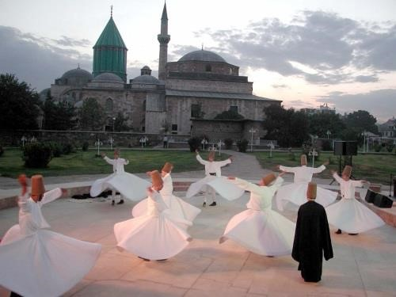
We visit the Mevlana Museum, the original lodge of the Mevlevi Whirling Dervishes, a mystical Sufi Muslim group. It contains the tomb and shrine of Celaddin Rumi, later known as the Mevlana (meaning ‘Our Guide’ in Turkish), who promoted the idea of whirling dervishes to become closer to Allah. In the following centuries, thousands of Whirling Dervish lodges were opened throughout the Ottoman Empire. Ataturk saw these lodges as effecting the advancement of the Turkish people and banned them from performing in 1925. A few orders survived and the Konya lodge was reopened as a cultural association in 1957. It is an important pilgrimage site.
After time for refreshments, we travel 45 min southeast of Konya to Çatalhöyük, a very important archaeological site. It is the largest and best-preserved Neolithic and Chalcolithic proto-city settlement in Turkey and a UNESCO World Heritage Site. Represented here is one of the oldest civilisations on earth and one of the earliest villages. The excavations represent a settlement of 300 mudbrick and plaster homes built in a unique streetless pattern of houses clustered back-to-back with roof access into the buildings. The site was occupied from about 6300 BC to 5500 BC. Its most striking and famous features are the shrines that were dedicated to what has been called the ‘Mother Goddess’. The Neolithic and Bronze Age cultures were remarkably advanced.
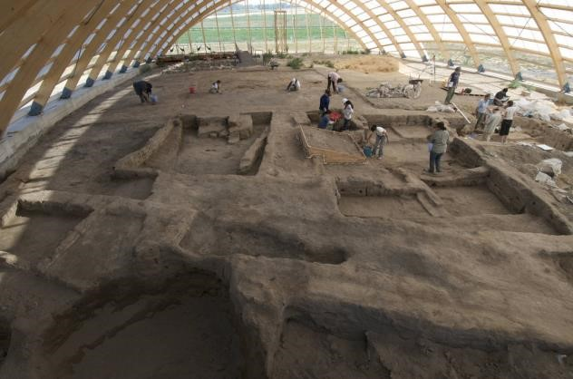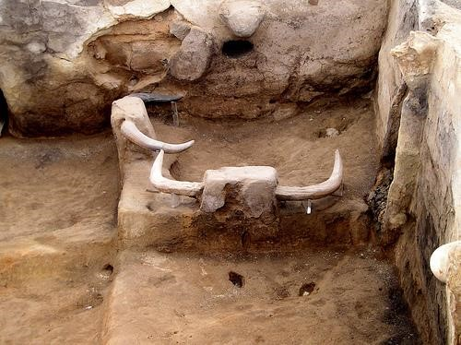

Archaeological excavations at Catalhöyük
The site was first discovered in the late 1950s and excavated by James Mellaart between 1961 and 1965. Çatalhöyük rapidly became famous internationally because of its size and dense occupation, and the spectacular wall paintings and other art uncovered inside the homes, such as modelled animal heads protruding from the walls. Starting in 1993, an international team of archaeologists led by Ian Hodder carried out new research. Çatalhöyük provides important evidence of the transition from settled village to urban agglomeration, but the interpretation of the structures has caused much debate.
We may also visit an older archaeological site nearby, Boncuklu Höyük, dating to 8 500 BC. At the Çatalhöyük Visitors’ Centre replicas of finds will be seen. Dinner will be enjoyed at a local restaurant.
Optional Whirling Dervish Ceremony. On our return to Konya, participants may wish to see this is a ritual dance representing a union with God. The dance appears on UNESCO's third proclamation of Masterpieces of the Oral and Intangible Heritage of Humanity.

THURSDAY 10 JUNE: AŞIKLI HÖYÜK – CAPPADOCIA - UCHISARI
We continue towards Aksaray along the ancient trade route to Persia. In the middle of a flat plain, we arrive at one of the best examples of Anatolian Seljuk architecture, the Sultanhan fortified caravanserai. It was built completed in 1239 by the Syrian architect, Muhammed Bin Havlan El Dimaski. After a fire in 1278, it was restored and extended and became Turkey’s largest caravanserai.
Our next stop is the archaeological site of Aşıklı Höyük, a 4-ha settlement mound in an area of volcanic tuff . It was settled in the Pre-Pottery Neolithic period. First investigated by Prof. Ian Todd in 1964, he emphasised the importance of obsidian in the area based on over 6 000 obsidian pieces collected from the surface layer alone. Extraction of the obsidian source is likely to have occurred at the time of Palaeolithic nomadic hunter-gatherers. The occupational period Aşıklı Höyük
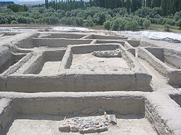
was from 8200 to 7400 BC, extracted from three layers with a total of 13 phases. More than 400 rooms and 70 individuals buried under the floors were found. There is a variety of skeletal body postures, from foetal positions to extended skeletons facing upwards. The male population had individuals up to the age of 55–57 years of age, while the majority of females died between the ages of 20 and 25. The skeletal remains of these women show spinal deformities indicating that they had to carry heavy loads.
We continue to central Cappadocia with its Aşıklı Höyük excavations in 2009
impressive geological formation. The Taurus
Mountains emerged some 65 to 62 million years ago. At this stage, deep crevasses and subsidence occurred. Magma from the earth’s core emerged through these crevasses and created a chain of volcanoes. Strong eruptions followed and volcanic lava, ash and tuff covered the hills and valleys, creating today’s huge plateau with tuff thicknesses of almost 100 m. The typical morphological structures of Cappadocia are the result of thousands of years of continual erosion that has shaped the tuff into the strangest pyramids and cones.
At Uchisari we book into the Kale Konak Cave Hotel for two nights www.kalekonak.com. The hotel is full of local architectural ambience. After time for refreshments, we set out to see Paşabağı or Monk’s Valley with its mushroom-shaped fairy chimneys and Devrent Valley with its animal-shaped fairy chimneys. Paşabağ is one of the best areas to see fairy chimneys up close. Here one finds classic mushroom- shaped formations with multiple caps. Some of these were used by monks as places of retreat in carved spaces. The Devrent Valley near Avanos is one of the most unusual places to see fairy chimneys. There are no trails in the traditional sense, no churches
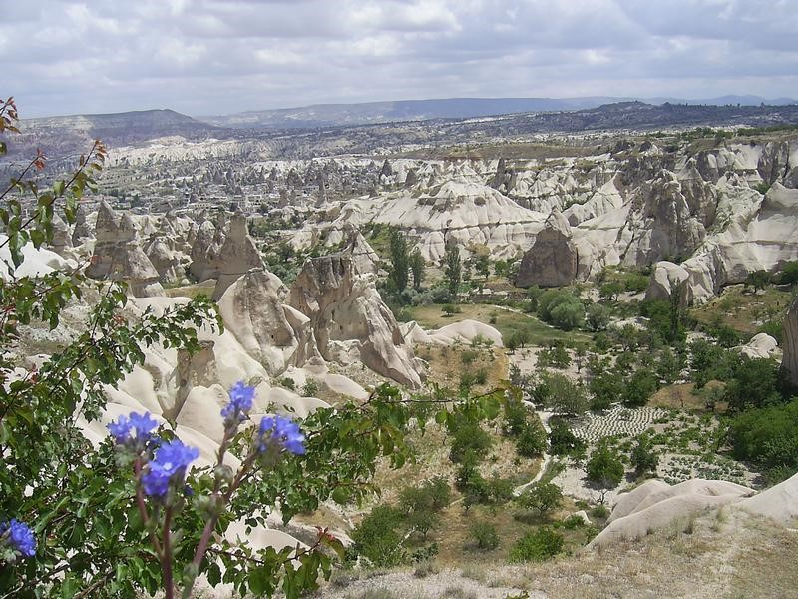
and no carved dwellings. Both valleys are easy to explore, and it is not about walking long distances but about observing and letting your imagination do the work. We have dinner in Avanos at a restaurant by the Halys (‘Red’) River.
After dinner there will be a lecture on the history of a traditional handcraft of Cappadocia: weaving the rug. This has a deep historical and archaeological background.

FRIDAY 11 JUNE: ESENTEPE - GOREME MUSEUM – BAGLIDERE VALLEY
Participants can choose to rise at 04:45 for an optional hot air balloon expedition over the Cappadocian landscape. Soaring high above Cappadocia in the early light of dawn is an exhilarating experience. Participants return in time for breakfast.
Depart for Esentepe for a panoramic view of the lunar landscape of the Göreme Valley where we will visit the Göreme Open-air Museum, is a monastic complex of cave churches and chapels covered with frescoes. Most of these date from the 10th to the 13th centuries and many have a central cupola supported by columns. There are rock-cut tombs in the north annexes of several churches. Among the most famous churches are Elmalı, the smallest and most recent of the group; Yilanli with fascinating frescoes of the damned in serpent coils; Barbara; the Dark Church of Karanlık; Carıklı; and the Tokalı Kilise or Buckle Church, which has beautiful frescoes depicting scenes from the New Testament. The museum is a UNESCO World Heritage Site.
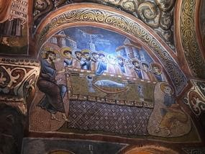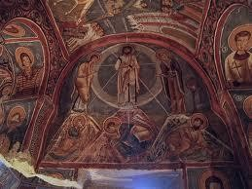

Karanlık Church (The Dark Church)
In the afternoon, we will hike in the lovely Baglidere Valley. This 5 km walk will take us about 90 minutes. With an elevation of just 163 m, the difficulty is moderate.
Dinner is at a local restaurant. Apart from its wonderful wine, Cappadocia is known for its slow-cooked tandoor-style clay-pot casseroles of lamb, chicken or vegetables.
After dinner tonight we will have a lecture on the history of another traditional handcraft in Cappadocia at a traditional pottery atelier.

SATURDAY 12 JUNE: DERINKUYU – TYANA - OSMANIYE
Our day starts with a tour of the underground city of Derinkuyu, the largest rock-cut underground city in Turkey with an estimated 18 to 20 floors below ground level that housed up to 20 000 people. It is believed to have been excavated by the Hittites and was used as a shelter against Arab raids and religious persecution between the 6th and the 8th centuries. Each floor could be closed off separately on the inside by large stone doors.
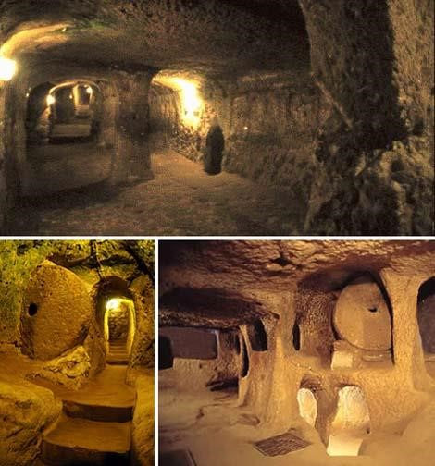
Derinkuyu, an underground city for 20 000 people

Derinkuyu had the same facilities found in the other 35 underground complexes across Cappadocia, namely wine and oil presses, stables, cellars, storage rooms, refectories and chapels. Unique to this complex, however, is a spacious room on the second level with a barrel-vaulted ceiling and rooms on the side, which was most likely used as a religious school. A vertical staircase between the third and fourth levels leads to a cruciform church on the fifth level.
Following this fascinating visit, we depart for Osmaniye, travelling off the beaten path to southeast Anatolia. We stop at the Eski Gümüşler or ‘Old Silver' Monastery. This Byzantine-era cave monastery was built in the 10th century and was in use until the Greco-Turkish population exchange in 1924. The monastery and its frescoes, which have been restored, and an underground settlement is one of the best preserved and largest of its kind in Cappadocia. Its different sections open to a central courtyard.
Continue to Tyana, known as Tuwana during the Iron Age and Tūwanuwa during the Bronze Age. This city in modern Kemerhisar was the capital of a Neo-Hittite kingdom in the 1st millennium BC. Tūwanuwa was an important cult centre, and its local pantheon was headed by the Storm god Tarḫunzas and his consort, the goddess Šaḫḫaššara. Tuwana was a powerful state by the time of the Neo-Assyrian king Sargon II (ruled 722–705 BC). It was one of the last still independent Tabalian kingdoms, although it was coming under the pressure of both the Neo-Assyrian Empire and the kingdom of Phrygia. However, it later appears to have come under direct Assyrian rule. In Kemerhisar we will visit the Roman Aqueduct, Sacred Pool, etc.
Via Tarsus, the birthplace of St Paul, and Adana we reach Osmaniye. We overnight at the Reiwa Hotel (1 night) www.reiwas.com.tr/en/gallery.html. Dinner will be at a restaurant in town.

SUNDAY 13 JUNE: KARANTEPE - GAZIANTEP – ZEUGMA MUSEUM
Our first visit today is to the Karatepe-Aslantaş Open-Air Museum, 30 km from Osmaniye. Karatepe (‘black hill’) is the location while Aslantaş (‘lion stone’) refers to the lion figures on stone sculptures inside the surrounding national park. Karatepe is on the historic caravan trail, called Akyol (‘white road) used by Hittites, Crusaders and more recently by Yörüks (Turkish nomads). The site contains the remains of an ancient fortress dating back to the 8th century BC. The walled settlement was founded by the king of Quwê, a Neo-Hittite kingdom and conquered by the Assyrian Empire either in 720–725 BC or in 680 BC.
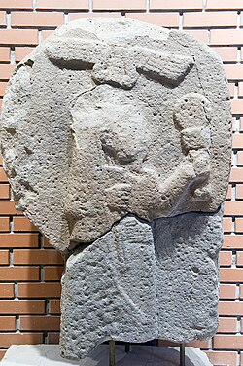 | At the Karatepe Museum:  Left: Goddess Kubaba carrying a mirror; 9th century BC  Below: A Hittite bull statue  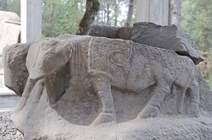
The inner and outer walls of the fortress are 4 m to 6 m high and 2 m to 4 m thick. The double stone walls were filled with rubble and soil. The fortification stretched over an area of 376 m by 196 m and had 34 bastions and two gates, one with two lion stone statues. The walls of the two chambers flanking the gate are covered with reliefs that depict the faith and way of life of that time. Inside the other gate, there is a stone statue of the Egyptian dwarf deity Bes and a 3 m tall stone statue of the Phoenician thunder god Baal, as well as two stone statues of sphinx. The flanking chambers contain several reliefs and a Karatepe Bilingual that enabled the decryption of Anatolian hieroglyphs, which go back to the 20th century BC. On a hill, grain wells and palace ruins are situated.
Our journey continues to Gaziantep to visit the magnificent Zeugma Mosaics Museum. The architectural decorations of Roman houses in ancient Zeugma (which we will see the next day) on the Euphrates River, dating from the 2nd and 3rd centuries AD, comprised
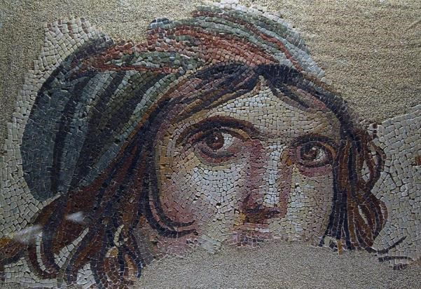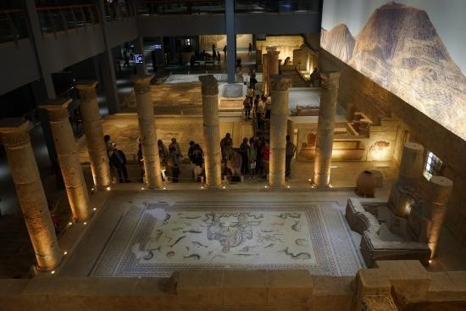

exquisite mosaics and frescoes, a unique collection of pictorial art reflecting private taste in a cosmopolitan city in the Hellenistic and Roman East. They include unique renderings of ancient literature and Greek and Greco-Roman mythologies. Some have Greek captions and bear the signatures of the artists and the names of the patrons who commissioned them. Most representations of mythological scenes in the Zeugma mosaics are ichnographically unknown depictions possibly emulating famous works of the Roman world. In one you find yourself in the middle of the Trojan War, in another you are enthralled by the Gypsy girl’s piercing eyes. As parts of Zeugma were to be submerged by the waters of a new dam in the 1990s, rescue archaeology brought the architectural decorations to the new Zeugma Museum.
We overnight at the Tugcan Hotel for one night (www.tugcanhotel.com.tr/en/index.html) and end the day at the colourful market, one of the best markets on the tour. Dinner will at a restaurant in the market/old city area. The best food in Gaziantep are meat pizzas with very thin bases, salad, a type of naan, a mixed grill (sausage, beef) and baklava

MONDAY 14 JUNE: CARCHEMISH - ZEUGMA – SANLIURFA – MUSEUM
Today we visit two important archaeological sites, Carchemish and Zeugma, and our travelling distance will be 163 km. Carchemish, which straddles the border of Türkiye and Syria, is one of the most important settlements in Near Eastern archaeology. As the city was located on an important crossroad linking Anatolia with Mesopotamia and Egypt, it was the scene over millennia of battles between Hittites, Egyptians, Assyrians andBabylonians, amongst others. Nebuchadnezzar, king of Babylon, defeated Necho, king of Egypt, here in 605 BC. Excavations indicate that the site was inhabited as early as the
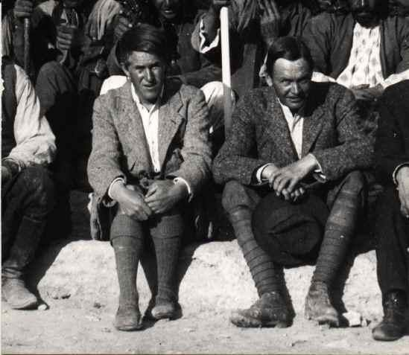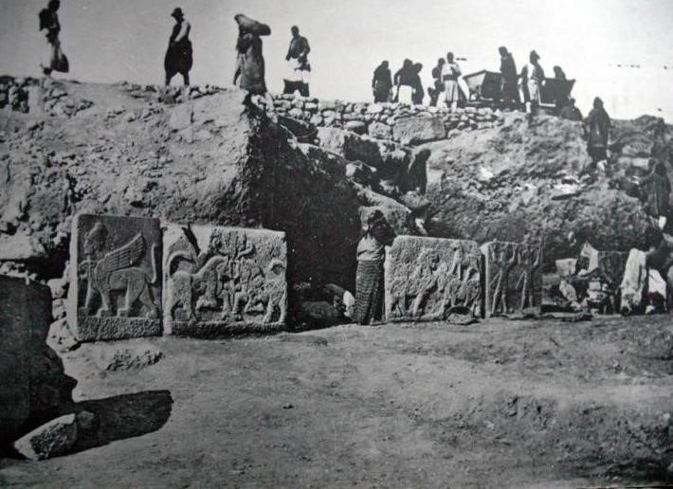

Sir Woolley and Lawrence of Arabia at Carchemish excavations in 1910
Neolithic period. The epic of Gilgamesh portrayed here on reliefs date to the Hittite period. A Türkiye-Italian team is conduction the most extensive excavations here in nearly a century, building on the work of British Museum teams. We will see the paved road to the palace, the foundations of the palace and its inner buildings, and a significant stepped street to the acropolis.
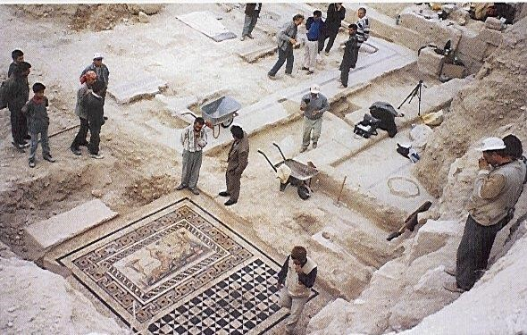 Zeugma archaeological site
The other important archaeological site is the ancient trade centre of Zeugma, one of the ancient world’s largest cities and one of the foremost cities of the eastern frontier of the Hellenistic and Roman worlds. It is located on the banks of the Euphrates River at one of the few points where the river could be crossed. Founded as a Greek settlement in 300 BC, it was conquered and renamed Zeugma (‘bridge’ in ancient Greek) by the Romans in 64 BC. The centre was abandoned when Sasanians invaded from Persia. Roman houses decorated with exquisite mosaics and frescoes, as seen by us in the Zeugma Mosaics Museum. Excavations have unearthed Roman villas, mosaic pavements, statues and other treasures.
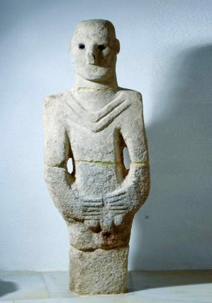
We continue through the upper Mesopotamian Fertile Crescent between the Tigris and the Euphrates Rivers to colourful Sanliurfa, the city of Edessa of former times. It was long an important trading centre on the Silk Road between China and the Roman Empire. Here we visit the Archaeology Museum of Sanliurfa, Turkiye’s biggest museum complex, 200 000 m² in extent. It houses a breath-taking display of objects from Göbeklitepe, which we will visit the next day, and other early Neolithic, Chalcolithic and Bronze Age sites in the region. Another hall is reserved for Assyrian, Babylonian and Hittite artifacts. The most important artefact found here is the world’s oldest statue ever to be discovered until now, the approximately 11 000-year-old, full-size human figure found at Balikli Göl. Named Urfa Man, it represents ‘the God of Eroticism’ or ‘the God of Reproduction’ and stood in a Neolithic temple.
Then we will visit the nearby Haleplibahçe Mosaic Museum. It was built directly over the archaeological excavation site of a late Roman villa dating back to the 5th to 6th centuries. The main highlight of its collection is the magnificent perfectly preserved floor mosaics. We will see unique works of art in their authentic historical setting, see first-hand how the floors of luxury villas looked nearly 1 500 years ago and appreciate the high craftsmanship of ancient artists.
We overnight at the Nevali Hotel (www.nevalihotel.com). Tonight we enjoy a Farewell Dinner at the Urfa Saray Konukevi with traditional music.

TUESDAY 15 JUNE: GÖBEKLITEPE – ŞANLIURFA - ISTANBUL
Today promises to be a most exciting day as we will be visiting 11 500-year-old Göbeklitepe, the oldest spiritual complex to have been found in the world, as well as
two similar sites nearby. Twelve similar sites are now under investigation, 11 of them having come to light in just the past decade. But it is believed that there could be 52 temple sites in the area.
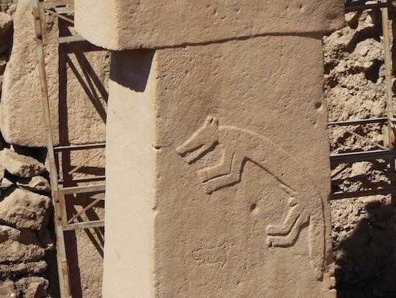
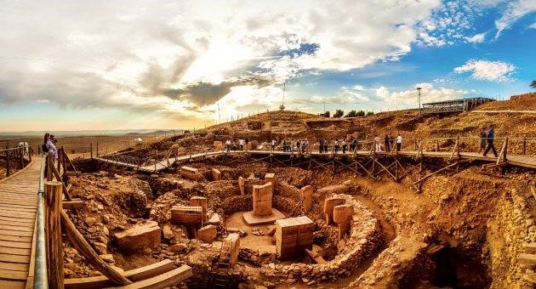
A drive of 80 km brings us to Göbeklitepe, built some 6 500 years before Stone-henge. Its discovery contradicted the long-held belief that the introduction of agriculture preceded the construction of large structures, since Göbeklitepe was created by hunter gatherers some 2 000 years before agriculture was introduced. This mound was developed over some 1 300 years from 9 600 BC and backfilled in 7 500 BC. Groups of about 200 persons may have been involved in site constructed a month at a time, obviating the need for agriculture. After Göbekli Tepe, we will also visit the mound of Karahantepe.

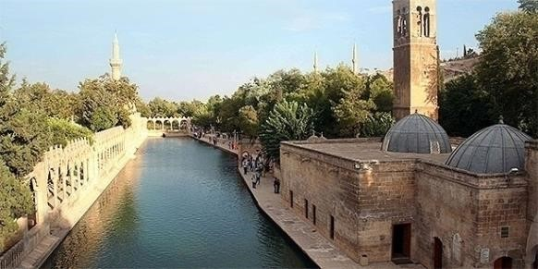
On our return to Sanliurfa, we have a walking tour of the city of the Prophets. It is widely believed that Prophet Abraham was born in a cave in the rock beneath the castle next to the sandstone-coloured Mevlidi Halil Cami Mosque. Visit this site and walk up to the Citadel of Edessa, which is the best place from which to appreciate Sanliurfa 's unusual colourfulness and the Gölbaşı Park with aits central rose garden below. Next, we may visit the Rizvaniye Mosque, which is the most picturesque site in Urfa. Its beautiful structures surround the Fishpond of Abraham. At one of Türkiye’s most atmospheric bazaars we will enjoy stalls still surrounding a network of ancient hans. Pass time in the plane-tree shaded courtyard of the 16th century Gümrük Hanı where the men play backgammon over endless glasses of tea – you could believe yourself back in the Middle Ages.
18:00 Depart for the Sanliurfa Airport for our flight TK2247 to Istanbul at 20:35.
22:35 Arrive at Istanbul International Airport. We now have time for a meal or refreshments at (for own account) and shopping before checking in for our flight to Johannesburg.
23:30 Check in for flight TK 42 to Johannesburg

WEDNESDAY 16 JUNE: ISTANBUL – JOHANNESBURG
01:35 Depart for Johannesburg
10:30 Arrived at OR Tambo Airport Johannesburg

TOUR PRICE

Per person sharing ex Johannesburg: R111 250 plus Euro 250*

Per person sharing ex Cape Town: R111 900 plus Euro 250*

Single supplement: R 20 400

*The Euro price component will be collected at various times during the tour to cover donations to archaeological sites where archaeologists may take us around, gratuities for our national tour guide and driver, and small out-of-pocket expenses incurred on behalf of the group.

Included in the tour price
All tour arrangements as per the itinerary, including economy-class airfares from Johannesburg to Istanbul return (note: taxes on air fares are subject to change and this could affect the final tour price); ground transportation in an air-conditioned and insured luxury vehicles 13 nights of accommodation in charming hotels as indicated or similar based on double or twin-room occupancy (or single rooms where this option has been chosen by the participant); en suite rooms with air-conditioning and free Wi-Fi; breakfast and dinner daily as indicated; 1 ℓ of mineral water/person/day; hikes in Cappadocia; a tour leader from South Africa; national English-speaking tour guide throughout the tour; archaeologists to show us around their sites where archaeological teams are on site; experienced English-speaking driver; all admission fees to the sites listed; tolls and parking fees; local taxes; donations to archaeologists; gratuities and tips to our national guide and driver.

Not included in the tour price
Any meals not indicated in the programme; alcoholic and non-alcoholic beverages; hotel extras and personal expenses; any optional visits and entertainment; porter services; travel insurance; add-on fares from other centres in South Africa.

Passengers joining from outside South Africa will receive a credit against the tour price for the three group flights and must arrange their own flights throughout.

Cost of optional tours (payable direct in Türkiye)
- Whirling Dervishes in Konya (1 hour) Euro 45 per person
- Hot Air Balloon tour in Cappadocia (1 hour): please advise when booking tour
- Royal Queen Flight 20-24 persons Euro 230 per person
- Royal Queen “Plus” maximum 16 persons Euro 280 per person

IMPORTANT TOUR INFORMATION

Tour organiser and leader: Reinoud Boers, 5 Henry Road, Rivonia, Sandton; PO Box 2196, Rivonia, 2128; cell & WhatsApp: +27 82 566 6295; email: fox@boers.org.za.
Tour operator in Türkiye: Peten Travels, Halaskargazi Caddesi 183, Helal Apt. D7 34381, Sisli, Istanbul; www.petentour.com; petenturizm@petentour.com; cel/WhatsApp: +90 532 316 63 21.
Emergency contact during tour: The most convenient way for you to be contacted during the tour is via Ms Iffet Ozgonul on the WhatsApp number above.
Tour conditions and terms: Please refer to the Tour Booking Form.
Travel conditions in Türkiye: Türkiye is very tourist-oriented and good tourist standards can be expected. However, conditions may be different from the standards one is used to. On a few days, long distances will be covered and some of the roads to be travelled may be torturous in part.
Climate: We will be travelling in spring, which is one of the best times to visit Türkiye. The climate is comfortable and average day temperatures range from 25 to 28 °C during the day and 10 °C at night. The chances of rain in June are low.
English is generally understood.
Time: Türkiye is on Standard Time, two hours ahead of Greenwich Mean time and one hour ahead of South African time.
Ground transport: Luxury air-conditioned coaches with Wi-Fi where reception allows.
Accommodation: We will stay throughout in hotels equivalent to three stars, including one traditional cave hotel. They will offer you a mix of luxury, authenticity, modern comfort and charm in en-suite and airconditioned rooms. If double beds are not offered, twin-bedded rooms will be provided to couples. Free Wi-Fi is included.
Meals: Breakfast and dinner daily, as specified. Most dinners will be at local restaurants. Lunchbreaks will allow time for the purchase of refreshments and snacks.
Tour leader: The tour will be accompanied throughout by a tour leader from South Africa.
National tour guide: A professional, registered, English-speaking guide will accompany the group.
Archaeological experts: Every effort will be made to ensure that archaeological experts join the group at the main archaeological sites, but arrangements can only be made in April/May 2027 when the season’s archaeological work has begun. Archaeologists provide their services on a voluntary basis. Sites where we could be accompanied are Troy, Laodicia, Sagalassos, Çatalhöyük and Boncuklu Höyük, Aşıklı Höyük, Zeugma, Carchemish, Göbeklitepe and Karahatepe.
Passport: Passports must have a validity of at least six months and have at least two empty pages.
Visa: Participants entering Türkiye on a South African Passport must apply for an electronic one-month single-entry visa via the website www.evisa.gov.tr. EU, UK, US, Canadian and Australian passport holders do not require a visa.
Travel insurance: Travel insurance is a requirement for all and details will be provided.
Health precautions: Travellers should be up to date with routine vaccination courses and boosters. Vaccinations against Hepatitis A, Hepatitis B and typhoid are recommended.
Health masks: To protect fellow travellers, participants who feel a cold or flu coming on are requested to start wearing a health mask immediately until the danger of infection has passed.
Diarrhoea: Take care with the water you drink and the food you eat. Bring along suitable medicine, such as a diarrhoea antibiotic and rehydration medication.
Water: Only bottled water should be drunk in Türkiye. 1 ℓ bottle of water will be provided per participant per travelling day. Bottled water is freely available.
Religion and holy places: Most Turkish people are Muslims, but the society is modern and predominantly secular, so Western dress style prevails. About 20 per cent of the female population wear the tessitura, a light cover-all topcoat and a headscarf in public. Turkish law outlaws the veil. Burka wearers are most likely foreign visitors. When visiting a holy place, please speak quietly, avoid walking in front of worshippers performing prayers and do not use a flash when photographing.
Clothing: Dress determines first impressions and how you are received. Dress comfortably and informally. Light cotton clothing is recommended but bring something warmer for colder places. Shorts are fine to wear, except in mosques and churches, where modest, conservative clothing rules: long pants and shirts for men and knee-length dresses, or skirts and elbow-length blouses and headscarfs for women. Comfortable but sturdy, closed shoes with rough soles are advisable. Dress at dinner is generally ‘smart casual’.
Things you may want to bring along: Light rain gear, sunhat, sunblock, sunglasses, wet wipes, hand sanitiser, personal medication, eye drops, insect repellent, toiletries, swimwear and a bathing cap, adapters, binoculars, photographic equipment with adequate SD-card capacity. A money belt is always useful.
Luggage: For your own comfort, keep luggage compact. Use travel locks and affix address details to the inside of luggage. A daypack will be handy for carrying water etc.
Currency and exchange rates: There is no need to search for Turkish lira (TRY) in South Africa, even though smaller payments in Türkiye can generally only be made by cash. Bring at least part of your spending money in Euro, which can be exchanged easily at currency exchange booths. ATMs linked to banks are a good option for drawing additional funds and often offer the best exchange rates. Hotels and airport currency exchange facilities are not recommended.
Exchange rates on 04/09/2026: 1 ZAR = 3.04 TRY 1 TRY = 0.33 ZAR
Credit cards and ATMs: Credit cards are accepted by most hotels, large shops, shopping malls and restaurants, but not by taxis. The most popular card is Visa. However, credit cards are may not be accepted away from major cities. It is illegal for merchants to charge you a komisyan of 2% to 4%.
Shopping: Türkiye offers a wide range of beautifully handcrafted items. Bargaining is common and it is customary for you to be offered a cup of tea if you visit a shop. Vendors can be pushy and aggressive. If you ship items overseas, ensure that you keep receipts and save copies.
Cell phones operate throughout Türkiye, but international calls are very expensive. Use WhatsApp.
Electricity supply in Türkiye is 220 V, 50 HZ and the round prong European style plug with a hole for an earth pin fitting into recessed wall sockets is in use.
Tipping for group dinners is included. When eating on a non-group arrangement, a tip of 10% to 15% should be added based on service. One to two liras are usually left when having tea or coffee in a cafe. Leave from 50 kurus or 1 lira at public toilets.
Photography: Avoid photographing or videoing anything of a military nature. If you see the words Fotograf yapmak yasak observe the ‘no photographing’ sign absolutely. Some museums and sights may require the payment of a photo/video fee. It is best to check first when shooting cultural and religious scenes. Most people are happy to have their photos taken provided they are asked.
Safety: Türkiye is no less safe than any other country, but petty crime can occur as elsewhere. Keep in mind the following:
- Use common sense, particularly around tourist areas and crowded places like markets.
- Guard against pickpockets and bag-snatchers; hold your bag close.
- Keep wallets, mobile phones, cameras and jewellery out of sight as far as possible.
- Make especially sure to protect your passport, air tickets and visa documents.
- Never leave valuables lying around your hotel room.
- Carry a photocopy of your passport and other vital documents separately.
Fluids in hand luggage: Restrictions on fluid containers holding over 100 ml in hand luggage on international and other flights do apply.

